Merry Christmas and Happy Holidays from the Neergaards

Notes from Dick and Lois  The spirit for travel and adventure was as always willing, but alas dampened by the flesh in 2006…. choppy waters on the physical front. We did however make our annual Fall and Winter snowbird pilgrimages to Hilton Head. Thanksgiving was a particularly warming time, as sons Arthur and Peter, with his son Steven, were able to join us there.  During the rest of the year, Cincinnati’s estimable opera and theater season provided a quite sparkling backdrop to the pleasant social fabric, and we kept the blood moving in our veins by playing (at) tennis.  The Big Deal of the year for us was the fortuitous settling of the van der Werff’s in Cincinnati (see below).  Pleading decrepitude and senility (heh-heh-heh) (just kidding… I think), I again recruited the more interesting and certainly more energetic members of our family to compose their own sections to this letter. Accordingly: | 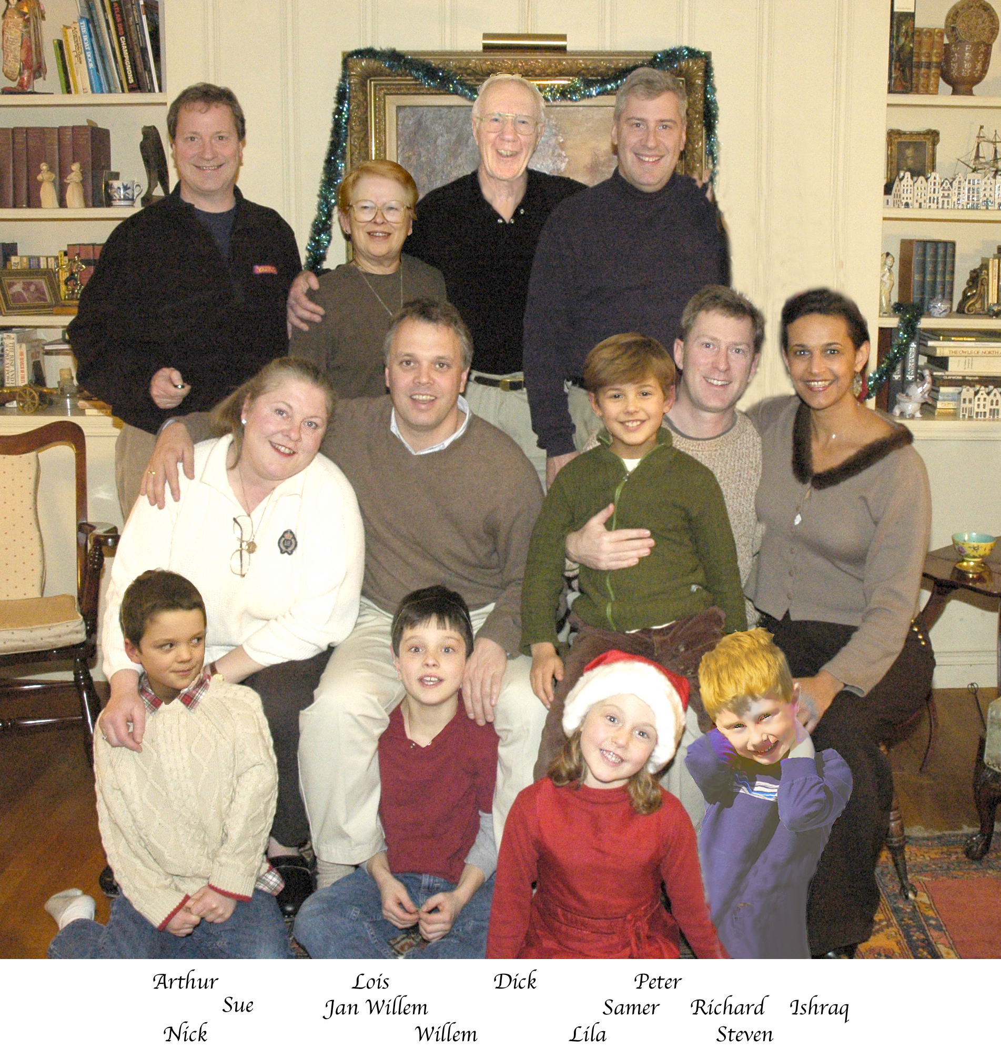

Notes From Daughter Sue, & Jan Willem (& G’kids Willem and Nick)
Last year we proudly announced that we did not change jobs or houses, did not add pets and did not get involved in any major home improvement projects. Well, this year we made up for it, doing all of the above in 2006. We changed jobs and houses, added pets, and have the plaster dust dancing in the sunlight even as we write. Here's how the game went for us in the year past:

In the summer we decided it was time to change not only jobs, but companies as well. After more than 14 years of making plastics for GE, the prospect of inventing and selling plastic as head of R&D and New Market Development for Lanxess, a spin-off of Bayer, was very appealing. So the change was made. This change brought two ancillary advantages. The first was that we had some very good family time in between jobs, time that was spent on two great vacations. First we went on an educational trip to New York City, Baltimore and Washington DC. Sons Willem and Nick learned everything about the Empire State building, Wall Street and Ground Zero. Then at Fort M^{c} Henry, they learned how the national anthem came to life (recognizing contemporary ethnic sensitivity, “José can you see….”). Then in DC our (now former) congressman, of Indiana's 8th district, gave us a personal tour of the Capitol.

After the Big City tour we spent almost a month in Europe: 10 days in Holland with friends and family, then almost 20 days in Italy where the Van der Werff brothers rented a medieval villa in Umbria, topped off with two days in Rome. It was a well-rested family that returned to the US, primed to get very busy with our new lives.

The second advantage of the job change is its serendipitous location in Cincinnati. This of course meant moving houses, and we can proudly announce that versus our previous move to Evansville, the weight of our household shrunk from 37,000 lbs to a mere 31,000 lbs. In the meantime we’ve settled into our new residence and now call ourselves West-Siders. And quite frankly, we don't understand what them snobby East-Siders are talking about. Why in Evansville, the entire city was West Side.
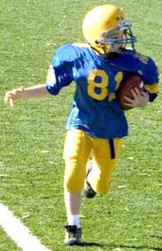 | Willem and Nick are now at St Ignatius' school. Nick is a second grader, and has truly excelled in his first year playing football. Willem is in 4th grade and is, along with his brother, going out for chess and wrestling.  That leaves one further change item to account for: the added pet, a kitten, which Uncle Art found and kindly gave to us. He’d named her Margaret, aka Meg, but her loony behavior soon earned her her current name: Nutmeg. | 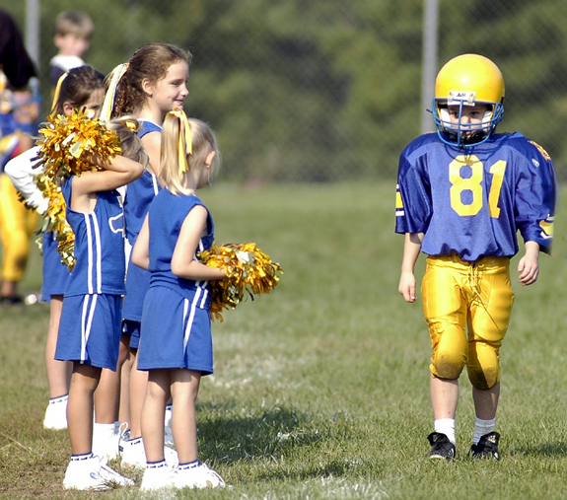

Notes From Son Arthur
I continue to work at P&G, doing research & development on their growing device business [editor’s interjection: In MY day ….harrumpf… P&G dealt with good, honest chemicals…. none of this gadget stuff]. This work includes travel, and sometimes I hit a trip right, eg my last supplier qualification, for which I “had to” spend 6 days in Venice (and not the one in California!). On the home front, my cat collection grows as it went from three to nine this past summer when I picked up an injured stray mother cat and five kittens. My apartment was hectic [a zoo? - ed] for a while, but has settled down since I found homes for all the kittens, the last of which went to my sister [see above brother-in-law’s wry characterization – ed] where it now dominates the two Labradors, and specializes in climbing Christmas trees.

I continue to pursue my passion for target shooting and now sit on the board of directors for one of the shooting clubs in Cincinnati. I’ve also started a small business selling specialty lenses for gun sights. The lens company remains a hobby though; I won't be quitting my day job at P&G anytime soon. [editor: while admiring his modesty in not mentioning it, it is nevertheless appropriate to report that Arthur’s annual classic blowout for Riverfest was as delightfully raucous this year as ever]. | 

Notes from Son Richard, and Ishraq (and g’kids Samer and Lila)
International School of Istanbul, and to great public acclaim, has set up her dance classes at the country club here.  Other highlights of the year: summer at our villa on the Red Sea; Samer and I swimming with dolphins; a Greek Island cruise; and a weekend in Deauville with our friend Tarek Sherif, hosted by his dad Omar.  (see http://www.neergaard.org/Omar/Evening.html Give it a couple of minutes to load fully!) | 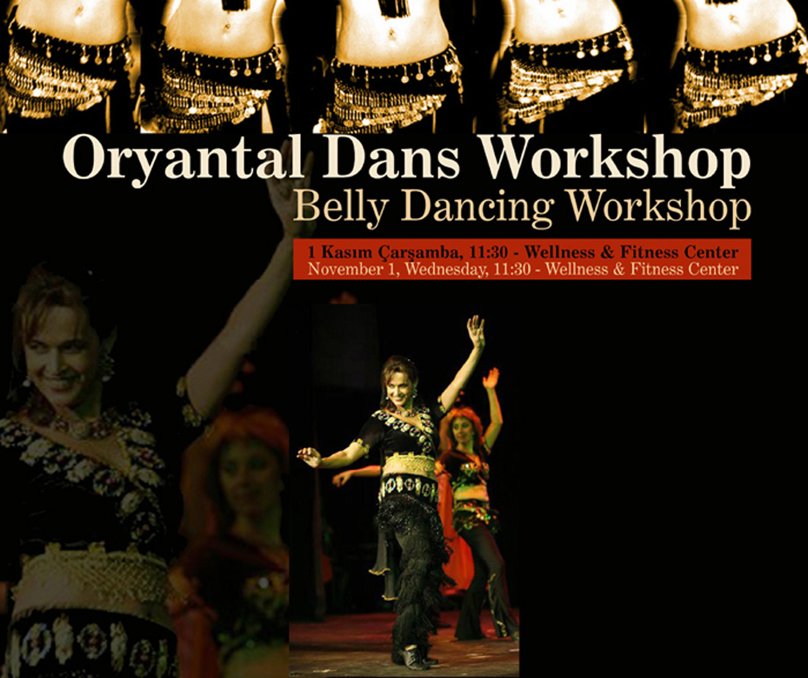  Poster describing Ishraq’s dance lessons
  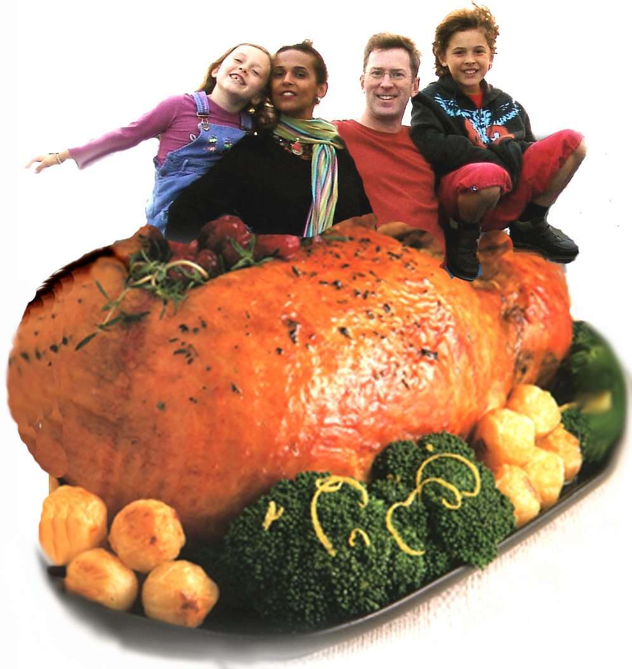 | We moved from Brussels to Istanbul this summer, where I’m now serving as general manager of Reckitt-Benckiser’s Turkish subsidiary. The job is great and the business is going gangbusters.  Ishraq has been elected to the Board of Directors of the

Notes from Son Peter
My job at lBM- designing, then giving training sessions in the use of WebSphere (IBM’s business system coordinating software) for the company’s clients globally, now thankfully has me traveling less and in Pittsburgh more. Seeing the world was terrific, but staying put a bit more has given me a better a chance to “have a life”. “Life” in this instance means being with my son Steven as much as possible, rollerblading and playing tennis. Steven is now in kindergarten; he too very much enjoys playing tennis…. and t-ball, and soccer, and basketball. He roller blades and ice skates as well, and this year will be starting skiing and karate. In his spare time, that is. | 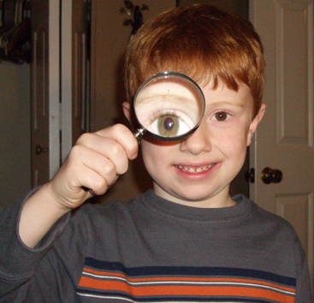

Editor: And they’ll all be with us for Christmas again this year– bless them!

Most cordially,

