Merry Christmas and Happy Holidays from the Neergaards

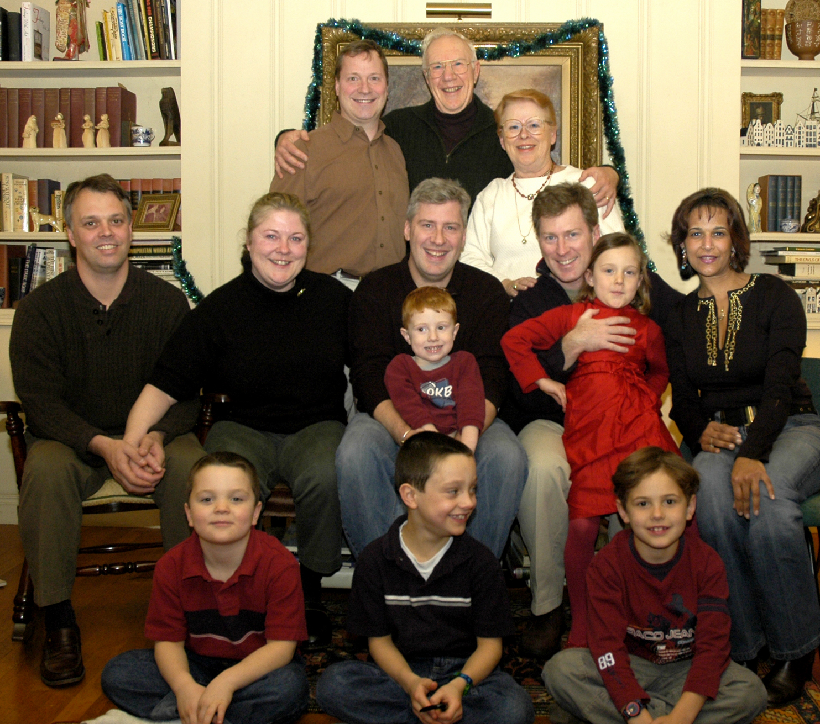

Dick & Lois’s report:
TRIUMPH! Finally, after having been thwarted on the previous two Christmases, I was able last Yuletide to get the all-in family photo I’d been yearning for (front of card). And even that was a near thing. Winter storms just before Christmas had closed airports, stranding Richard & C° in Florida (tough!), and had shut-down Interstates, cutting off our pilgrims from neighboring states. Miraculously though, by Christmas morning, everyone had succeeded in fighting through to the parental home. So that cover picture’s now a year old … but who’s counting? Actually this is just one of several dozen shots I insisted on everyone sitting still for. That entire gallery is on display on the website http://neergaard.org/Xmas04Site/FamilyPortraits/index.html If you flip through the full-sized images quickly, you can watch us writhe, squirm and do calisthenics with our facial muscles….. really quite entertaining.

Not much in the way of trips this year for Lois and me (one of the things Lois feels damned well at liberty not to do anymore since she reached the freedom of 70, is fly). But we can drive to Hilton Head, and indeed we reside there for most of the winter, playing (at) tennis, and enjoying the balmy breezes in the palms amongst a truly delightful lot of fellow snowbirders. Our stay there is punctuated only by a return to Cincinnati for the Christmas gatherings of family and friends. During the November portion of our sojourn, son Peter and grandson Steven stayed with us the first week, and Peter and Arthur, both with their lady friends, came down Thanksgiving week. It was a lovely interval.

Toronto is also within driving range, and indeed we had a delightful visit in July with friends there (the Knox’s, tennis buddies from Hilton Head) We were treated to splendid theater, scrumptious restaurants, and yes, of course, tennis.

In September I went to Estes Park, Colorado (by myself, so got to fly!), for the fourth in what’s evolved into a biannual series of informal get-togethers of MIT fraternity brothers of the ’50’s, occasions which mesh warm moments of nostalgia with present day enjoyments. The magnificent setting in the Rockies was enlivened by the bugling of lots of rutting elk, which thrilled us, but made the locals downright grumpy. Funny thing - there’s been practically no change in mien perceptible (to us) among the brethren over the past half-century, beyond our now being a smidge more dignified-looking.

Cincinnati offers much to add sparkle to its general aura of contentment. The opera season produced an unforgettable Bohème, best I’ve ever seen. The art museum held a fascinating exhibit of the personal treasures and mementos of the last Czar (in which it was revealed that the owners of the premier restaurant in town, the Maisonette, are descendents of that czar’s uncle, the chap who assassinated Rasputin!). And the Showboat Majestic, which we’re assured is the only such theater still afloat and functioning in the nation, staged a repertory season that, beyond the charming quirks of a steam calliope and gentle rocking during performances as barges chug by, was truly enjoyable.

Now for the actually interesting part of this letter – our up and coming generations (they’ll all be here for Christmas again this year – bless them).

Arthur’s Report

Arthur’s business card says “Mad Scientist” (really!), and in the circle of inventors and technical trouble-shooters in which he travels, that’s a true accolade. When not applying brainstorms, he indulges his enthusiasms for competitive target shooting, and making wine (though never simultaneously). He’s also joined an Irish choral group (you know, Arthur O’Neergaard?) who, around the time of St Patrick’s Day, busily participate in entertainments around town – sometimes including actual singing. Arthur’s technological skills have recently been absorbed by esoteric production problems of a key P&G supplier in Mexico, requiring Arthur virtually to commute there. Alas, this has led to a diversion of his attention from the cat whom he’d trained to use the toilet, resulting in said cat’s skill deteriorating to merely unwinding the roll whenever the door’s left open. | 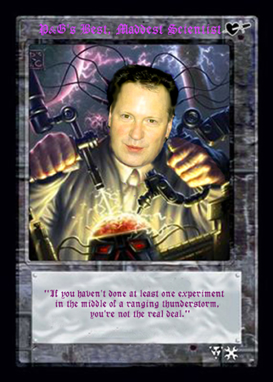

Richard’s Report (with Ishraq, and Samer & Lila)

- Richard is still cleaning the world one stain at a time, with Reckitt Benckiser. The family will be moving from Brussels to Istanbul, where Richard will be General Manager of Reckitt’s subsidiary in Turkey. Richard is already there; Ishy and the kids will follow when the school year ends.  - Real-estate spree: bought a house in Brussels and three in El Gouna Resort, Egypt (across the gulf of Suez from Sharm El Sheik). Since sold one, cancelled one but now will be buying one in Istanbul. Don't live in any of them. We rent.  - Samer, nine and in the 4th grade, is now on the swim team of ISB (the Brussels International School). He spent his summer when in Egypt water skiing, wind surfing, and fishing; and when in Belgium mountain-biking, roller blading and learning tennis, all scarcely interrupted by his breaking his arm.  - Lila, seven, in the 2nd grade, doing ballet and devotedly creating drawings, is cuter than ever (see http://neergaard.org/Lila/ ).  - Ishy’s still teaching dancing to ladies at the European Commission, doing shows at ISB, and is preparing for yet another move. | 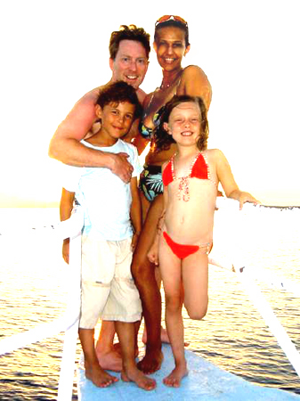

Peter’s Report (with Steven)
Peter designs courses on how to use IBM’s premier networking software, WebSphere, then presents them to the company’s worldwide clients (most recently in Chili and India). He gets the kinks out by rollerblading upwards of 40 miles a week (when traveling doesn't get in the way), playing tennis [editor’s comment: he’s very good and beats up shamefully on his old man], and volleyball. The rest of his universe is devoted to doting on his son Steven, and work, work, work. One cloud on the horizon: it’s really tough (and dangerous!) being a Bengals fan in Pittsburgh. | 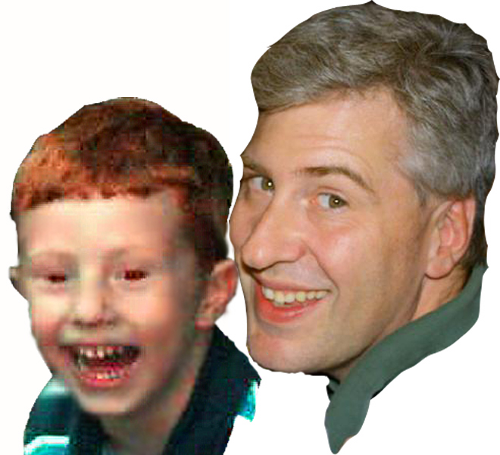

Jan Willem’s Report (and Sue, and Willem and Nick):
The Dutch-Hoosier van der Werff family had yet another busy year. Not that we moved, changed jobs, acquired more dogs or any of the other things we usually do in a year: it was just a year filled with stuff to do. Here's a sample:

Nick started the year being part of his school's wrestling team. Not surprisingly, given his chunky physique, he’s quite good at the sport: for instance, while he holds some poor kid down with one arm, he gestures with the other while discussing with his coach the perfect execution of a half Nelson. In school Nick is doing a good job, getting decent grades and ebulliently ensuring that the first grade teacher has to work for her money. In the meantime his maternally-inherited social skills are reaching full potential; Nick never misses an opportunity to generate a laugh or stir up a bit of action.

Willem had a great year (year, not just season) of baseball. He was elected to the school's all-star team and played in the Fall as well as the Spring, much to the pride of Opa, his Dutch Grandfather, who used to play ball as well. Willem’s also doing good work in the third grade, and getting solid grades. A highlight of his year, or so his dad sees it, was when on Grandpa's birthday, Willem got to accompany The Big Guys (dad, uncle, grampa) for a celebratory beer in an establishment of which the franchise is mostly known for the pair of owls in its logo. When Willem snitched to the waitress that it was Grampa’s birthday, thus triggering an envelopment by a bevy of singing, clapping, jiggling girls (T-shirts: “Delightfully Tacky Yet Unrefined”), Grampa, as he was being propelled to stage center, in exquisite retribution,
dragged the kicking and screaming Willem along with him into the nymphian midst, to share the ordeal. All part of growing up.

Jan Willem has been making yet more plastic for GE, which again required some travel as he built a factory in China and kept up with plants in Europe as well. The good news is that traveling has became a lot easier now that the status of Permanent Resident Alien has been achieved; in other words: he got his green card. A primary contribution to his being accepted was his demonstrated mastery of Evansvillian grammar.

Sue continues to be her marvelous social self. Entertaining, giving dinner parties, organizing auctions for the school…. everyone around her benefits. She’s on the board of Willem and Nick's school's PTO, where she constantly surprises both teaching personnel and PTO colleagues with creative ideas. And of course she does the full soccer-mom / baseball–mom, etc-mom stints. In her (a-hem) spare time, she’s assistant den mother of Willem’s Cub Scout Troop, and has just been made Cub Scout Commissioner of Nick’s (she doesn’t yet know what that is either).

And then, in addition to the three two-legged animals that she takes care of, there are three four-legged ones. The two dogs, when they think of it, enjoy chasing the cat, who simply disdains their advances. Otherwise they practice spewing mud about the house by doing agility tricks.

All these things keep Sue so busy that her passion for coin collecting has had to be reined in – for the moment. But they’re all worth it

