Neergaard Family Christmas Letter – 2003

“Snowbirding” – the retreat from November through February to Hilton Head Island on the Carolina coast, punctuated by a return to Cincinnati for the Christmas season - has become a regular and quite pleasant part of our yearly schedule. And indeed, Hilton Head is where this letter is being written in those intervals during which I can pry my gaze from the lazy wafting of the palm fronds, and detach myself from kinship with the ’gator basking on the far lagoon bank.

Our third not-exactly-biannual-but-close, informal MIT fraternity reunion of the classes of the ‘50’s (now there’s a title!) was held in Phoenix in March of this year. It was as always enormously warming to spend a few days with close friends of yore, brethren and spouses. As extra dividends, the galleries of Scottsdale and Sedona were a joy to traipse through, and the road looping to the west between Phoenix and Sedona proved to be a delight to drive.

In October Lois and I fulfilled our several-times-postponed ambition of driving to New England to watch Autumn leaves fall. We spent three weeks, wandering around the region visiting friends, ending up with a week amidst the glorious foliage of Smuggler’s Notch, Vermont. We returned home just long enough to get through the mail, then I flew to Europe for two October birthday parties – grandson Samer’s 7th in Belgium and long-time friend Trig’s 80 th in Germany. Home, again a few days turn-around, then off to Hilton Head for the month of November, where Weltschmertz is limited to the mourning of the morning’s bungled backhands and yearning wistfully for breakthroughs on the morrow.

Of course the more interesting doings in a family’s life come from those to whom Time is passing the baton. Sue and Jan Willem moved mid-year from the Netherlands to the US (Evansville, Indiana), where Jan Willem is serving as global manufacturing manager of GE’s plastic sheet business. Or I should say “whence” rather than “where”. “Global” does mean travel; he just got back from a dizzying three-week tour of his plants in Asia. Sue in the meantime is reveling in being Hostess in their lovely new house.

Arthur continues to create engineering solutions for P&G’s Product Development Division. Arthur’s always been a dog-loving man, properly disdaining cats, but who can resist feline wiles when projected at mega-strength by a seductively needful eight-month-old street kitten. “Sue will need a cat” he at first explained “when they move to the US”. But as it played out (to revert to New York-ese), “fuhgedaboutdit!”. In short order Arthur was hooked, and Oliver was here to stay, Sue being left to get her own cat. Arthur has now toilet trained Oliver. Really. (But he can’t flush. Oliver that is.) Arthur’s enthusiasm for biathlon has expanded into a keen interest in guns, and has led him to amassing a fascinating collection of firearms, which he keeps carefully locked away from nieces, nephews….. and Oliver.

Richard’s business (he’s General Manager of Reckitt-Benckiser’s Belgian subsidiary) and his family, both continue to prosper in Brussels. Richard motivates his staff by among other things, offering exciting non-monetary incentives for reaching goals, many of which incentives by (a-hem) sheer chance involve Richard's passion for fast cars, such as getting to spend a day driving race-cars around various of Europe's tracks. Richard’s enthusiasm for the sport is such that the scheme certainly works for him!
Ishraq, much applauded in the community for her popular Belly-Dance classes, was asked to organize a dance show for the annual fair of the International School of Brussels, which their children Samer and Lila attend. Recruiting the bravest from amongst her students, she choreographed, staged and starred in a performance that can only be described as wildly successful (CD on request).

Peter started his new life as a bachelor fittingly by moving house in January. Lois, Arthur and I helped; three stories in each residence, and the old calf muscles complained bitterly for a week afterwards. But it was helpful for Peter to move nearer the airport since his job as trainer and consultant with IBM (did you know that IBM has the largest consultancy business in the world?) keeps him well on the move – Sydney, Singapore, and Beijing being among recent destinations. He and his son Steven, bless them, spent Thanksgiving week with us here in Hilton Head (for pix, see < http://neergaard.org/HHdSites/Index.html > .

We’ll soon be back home to Cincinnati for Christmas, to be joined there by kids and grandkids – how wonderful! A week later, Lois and I will return to Hilton Head to recover, fondly reminisce, play (at) tennis – and simply abide, waiting out the Midwest’s Jan-Feb Gloom Period, then to rejoin our friends in Cincinnati once Spring starts appearing around the corner.

Merry Christmas to you from us all!
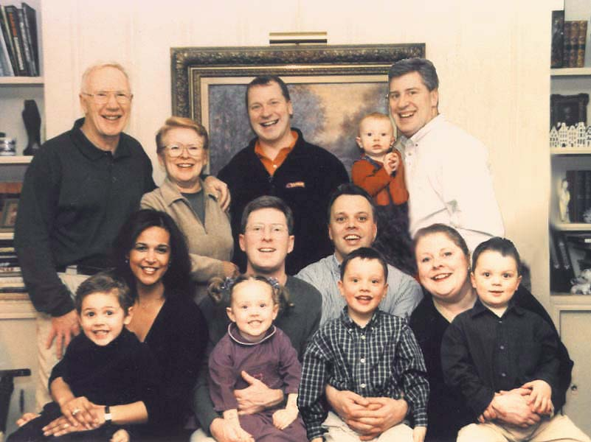
Dick Lois Arthur Steven Peter

Ishraq Richard Jan Willem
Sue
Samer Lila Willem Nicky

The above is a two-year-old picture, but alas is the last one I have of us all together. Silver lining - it makes us all look younger! Which is assuredly only right
for us adults; but for the grandchildren two years is an eternity, so more recent photos of them are called for:

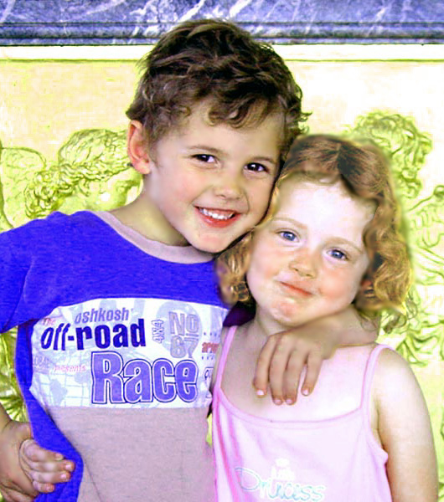 | 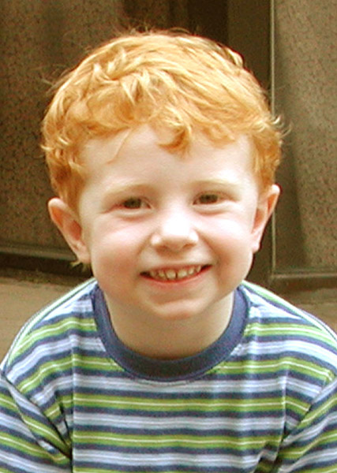 | 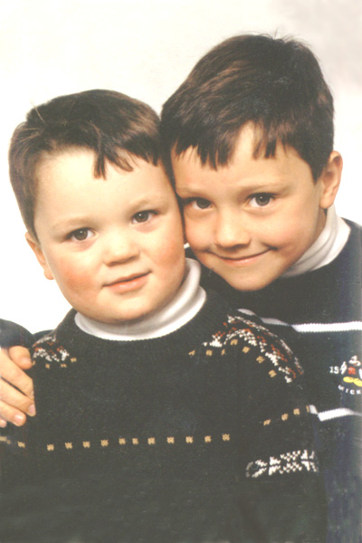
Samer and Lila | Steven | Nicky and Willem

(Top priority project this Christmas will be to update that Family Portrait!)

