Christmas Greetings from the Neergaards – 2002
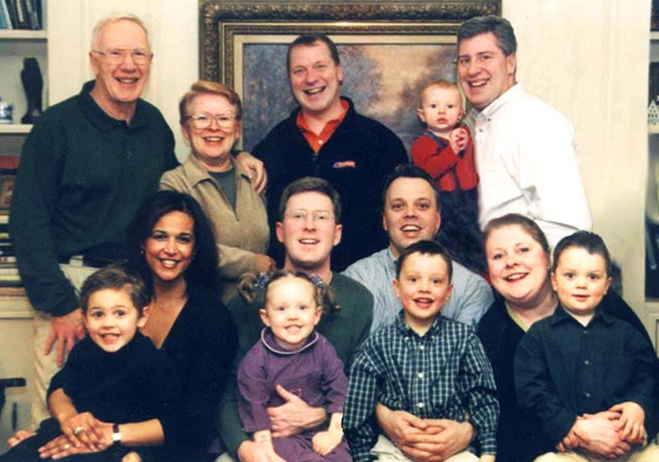
Dick Lois Arthur Steven Peter
Samer \ Ishraq Lila \ Richard Jan Willem / Willem Sue Nick

This photo was taken in a rare calm moment during Christmas last year. The whole family had assembled in Cincinnati - the Dutch, Belgian and Pittsburgh contingents, bless them, as well as us locals. The nightly scene of three mothers simultaneously trying to feed five small (and mostly jet-lagged) children in the ell of the kitchen, fathers hovering around the periphery offering jolly advice and brandishing video cameras, is burnt into the collective memory, right alongside other visits to zoos around the globe. It was all quite wonderful, but after Christmas subsided, Lois and I retreated to the balmy breezes and waving palms of Hilton Head for six weeks of R&R.

Then, in April….. well, it had to happen sooner or later, and this year it finally did - I turned 70. And what a gratifying transition! My three sons, son-in-law, and Trig, our close family friend of 40 years, gathered in Cincinnati, whence we went Out West, spending two weeks ambling by SUV through the canyon country between Death Valley and Monument Valley, choosing vehicles as inspired by the moment: a Cessna over the Grand Canyon, Navajo horses in Monument Valley, a narrow-gauge steam RR out of Durango, a jeep through the back country of Canyonlands. Arthur had fitted us all out with Stetsons and cowboy boots, bedecked with which we’d push through the occasional swinging doors, belly up to the bar, order us a whusky….. and the bartender would ask “What part of New York you guys from?”. Partway through this retreat into those magnificent, pristine settings of nature, we took out several days to steep ourselves in the cheerful decadence of Las Vegas, thus fashioning for ourselves a sort of spiritual sauna.

Our summer was quiet - tennis, gardening, projects, eg Lois continues to turn out handsome quilts - but brightened with highlights such as our local ATP Tennis Masters tournament and a truly excellent opera season ("Dead Man Walking" isn't pleasant, but it is terrific). Then in September I went to Europe to attend Trig's daughter's (my goddaughter's) wedding near London (Lois stayed home; she alas no longer does airplanes). I took the opportunity to go with daughter Sue to St Petersburg where we had a delightful week, and a particularly gratifying one, since Sue hadn't accompanied us on our “just guys” Out-West jaunt (though she had, as a lovely surprise, popped over from the Netherlands for the weekend to see us off). I also visited the village of Clonakilty on the southwest coast of Ireland, to renew acquaintance with the daughter of old family friends from Brussels, a young lady who’s just had her third novel published. And in Brussels there was a splendid celebration in honor of granddaughter Lila’s fourth birthday, occasioning a reunion not just of Brusseloise, but of visitors there from the States: son Arthur, and Pete and Luce Ifland. The entire trip consisted of 21 separate plane and train segments(and it all worked!)offering the excuse for yet another period of R&R in Hilton Head, this for the three weeks encompassing Thanksgiving week, during which we were most pleased to be joined by sons Peter and Arthur, and Arthur’s talented Belgian-artist friend Florence.

This last year was the first in memory in which none of our offspring moved. Sue and Jan Willem have remained on their bucolic island on the south-west coast of the Netherlands, although Jan Willem has a new job title: global Six Sigma Manager of GE’s styrene (plastics) business. Arthur continues to exercise his technological creativity with P&G Engineering in Cincinnati. Richard and Ishraq have resisted all inducements to leave Brussels, where Richard is general manager of Reckitt-Benckiser’s Belgian subsidiary, and Ishraq holds daily classes in belly dancing for the ladies of Brussels who take delight in having a bit of spark in their aerobics. It is of Peter that there is sad news; after four years of marriage, he and Lisa have divorced. Peter’s extensive travels are helpful at this stage; he still calls Pittsburgh home, but goes far afield to train IBM’s clients’ IT officers in use of the company’s networking product, WebSphere….. a job he relishes, taking him from Buenos Aires to Beijing; even as I write this, he’s in Singapore.

Please accept our best wishes for a joyful holiday season, especially heartfelt in these troubled times.

Cordially,

Dick and Lois

