Christmas Greetings from the Neergaards - 2001

Sent with special warmth this year, in recognition of the value of friendships in these troubled times
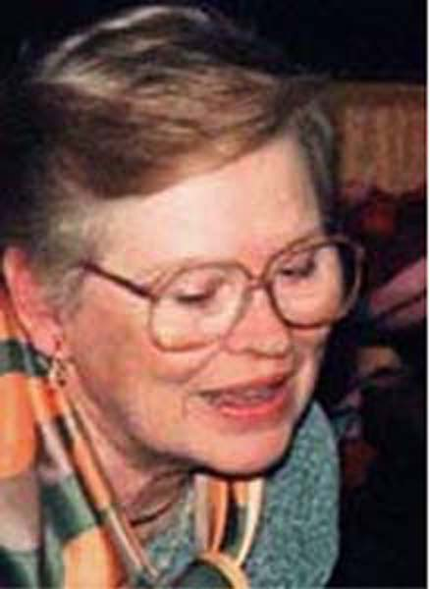 | After having been on the move for the better part of six months around this time last year, Lois and I thought it would be pleasant to take some time off from travel. And by and large, that's pretty much what we did ...... stayed home, did projects, pursued hobbies, socialized with friends, puttered around the garden, swatted balls on neighborhood tennis courts, and getting uplifted at local halls of culture and entertainment.  There were several exceptions to this pastoral quietus though, most notably when the family gathered - all fourteen of us - for two really quite satisfying weeks in March at the Club Med at Porte St Lucie, Florida - this was our "Family Christmas" for 2000. Another flurry of activity still to come within 2001 will be this year's Family Christmas, this one | 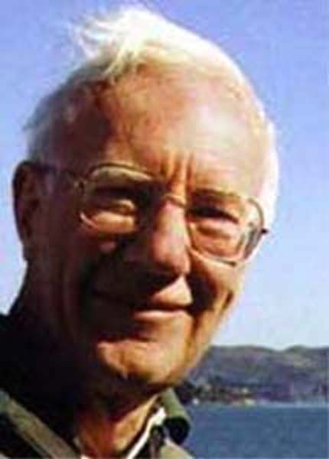
actually occurring at Christmas….. and at home. Our Euro contingent - two sets of parents, each with a three- and a five-year old - will be coming to stay with us for a week or two, bless their hearts (and pray for their safety), and our Pennsylvania contingent of three will join us all as well for several days. In anticipation of this delightful onslaught, Lois and I retreated to Hilton Head for Thanksgiving week and the two weeks following, to build our strength. We're now ready. I think.

THE KIDS
Our offspring's' exodus from the Low Countries in 2000 has, in 2001, reversed. Early this year Sue and Jan Willem returned from Chantilly (near Paris) to their island home in the Netherlands off the coast of Bergen-op-Zoom where GE's European plastics business is centered, and Richard and Ishraq, after having a year earlier moved from Amsterdam to London, in mid 2001 relocated to Brussels.

SUE AND JAN WILLEM

Sue has with enormous enthusiasm, taken up a cheerfully carefree version of coin-collecting - any coins, from anywhere. The folks at the local bank smile bemusedly as she comes in every few days to get a new bag of coins, returning the culled bag from last time. Friends and neighbors have been recruited to dig out their forgotten jars of foreign change, and eBay has proven to be...... what? a gold mine!
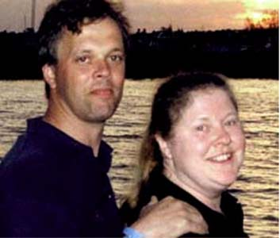 | Jan Willem, in July 2000, was made site manager of GE's ABS Plastics plants in France, which is what brought him and Sue to Chantilly. Then in January 2001, he became Manufacturing Manager for all three of the ABS plants GE has in Europe, bringing the family back to Bergen-op-Zoom Now yet another new job is in the offing, as GE shifts its organizational structure from horizontal to vertical. No official word yet about what or where. | 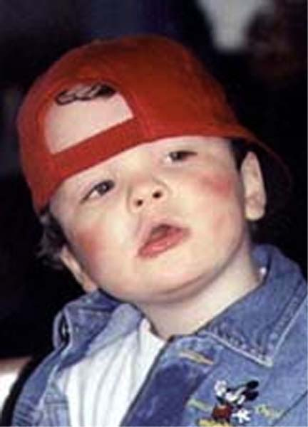  Willem Nickie

Their two children, Willem, five, and Nicky, three, are of course terrific.

ARTHUR


Snicker-snack went P&G's vorpal restructuring blade, and Arthur was in danger of being a downsizee in the company's latest cost-reduction campaign - his entire department, Upstream Engineering, had been one of those eliminated, and Arthur found himself among the battalions set loose to find themselves new jobs within the company - if they could; a daunting task in that environment. Then serendipitously, in a conversation at a social gathering, Arthur learned of a tough technical nut one of the P&G divisions had been trying for years to crack. He suggested several bright new approaches, generated some excitement, was invited to burnish his ideas, and lo and behold, the division created a new position for him. The technology involved is all very hush-hush; he could tell us of course, but then he'd have to kill us.

Arthur's still devoted to his run-and-shoot sport, Biathlon. There are several classes of competition. Arthur insists on entering the toughest - making him a forty-year old soapmaker amidst twenty-year-old semi-pro athletes. There are lesser classes, but Arthur says he would prefer being last but proud, to leading amidst a bunch of mamby-pambies. At least I think that's what he said.

Arthur's annual Riverfest party, at which friends of our generation as well as his get to watch in awe from his balconies as the Ohio River is being splendidly blown up, was its usual raucous success. Browse the festivities at:
http://w3.one.net/~neergaar/Riverfest2001/Riverfest

RICHARD AND ISHRAQ

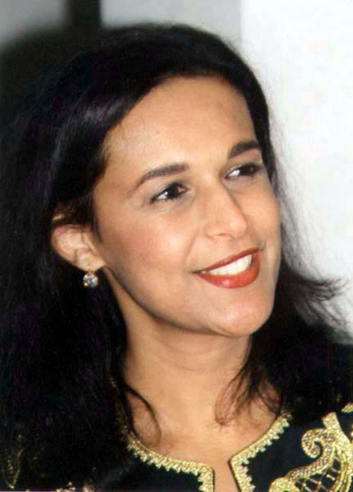
Richard has been appointed General Manager of the Belgian subsidiary of Reckitt-Benckiser, a European consumer-products company similar to P&G. In July he and Ishraq moved from London to Brussels, or I might say back to Brussels, since Richard had been born there. Richard's enthusiasm for fast cars has not diminished; his leisure-time relaxation (?) is whizzing on weekends around various European race tracks.

Ishraq maintains her consulting business - marketing to the Arab population on the West Bank - but her travel to the region has perforce been constrained, and she now does most of her work by teleconferencing.

She continues with pleasure to pursue her hobby: shopping for antiques, enjoying them for a while, then reselling them (for a profit!)
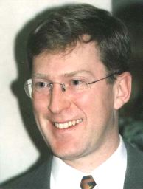

Their two children, Samer, five, and Lila, three, are of course terrific

Samer Lila

PETER AND LISA

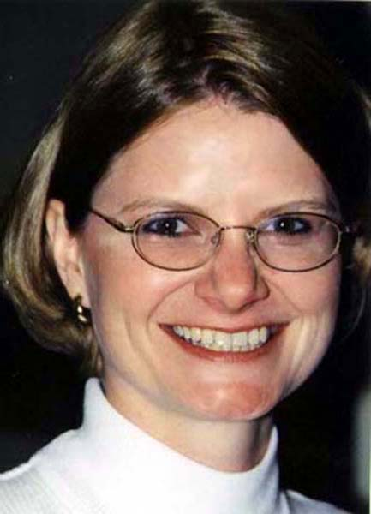
Peter hugely enjoys his work: he's now creating as well as running seminars to train the Information Technology officers of IBM's clients, in their use of "Websphere", a high-level networking system and one of Big Blue's key products. He's had to pull lots of all-nighters, but much of the design and administration can be done out of his local Pittsburgh office, so his travel schedule has been lightened. When a client is important enough, though, Peter is called upon to charge into the fray, so he's now occasionally flying back and forth to the French "Silicon Valley" on the Riviera (poor lamb), and with IBM's recent landing of the eBay contract, out to San Francisco.

Lisa and Peter wrestled over the winter with that so-vexing dilemma of modern times: whether Lisa would stay at home with the new baby, or continue with her career. What she really wanted was to be mostly a mom while still keeping her mind honed by
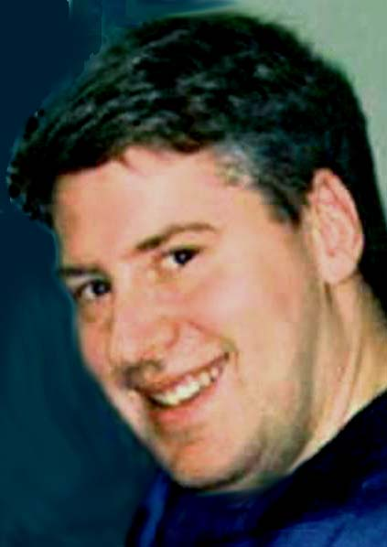

working part time. She knew that was unlikely: her position as compliance officer of PNC bank would almost certainly require her to be present full time. At the end of her maternity leave, she tried to work out a part-time arrangement within her department, but sure enough, no way - so she sadly tendered her resignation.  That afternoon Lisa got phone calls from two different divisions of the bank, each offering her a part-time position with them - hours of her choice - and….. a vice-presidency. She accepted the deal that brought with it the larger raise. |   Steven | Their son, being a First Baby, is of course even more terrific than usual.

____________________________________________________________________

