Neergaard Family New Year's Letter January First, 2001

The Baby Bombardment has resumed! After the arrival of our first two grandchildren in '96 and a second two in '98, a quietus prevailed through 1999. But - happily! - the millennium brought Steven, the first child of Peter and Lisa, on October 20th.
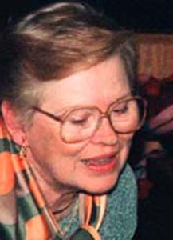  Lois | Lois and I continue in good health, cheerfully pursuing our roles as retired empty-nesters, spending our time traveling, playing (at) tennis, gardening, socializing, going to theater and opera, and enjoying undertaking whatever sundry and whimsical projects take our fancy at the moment. | 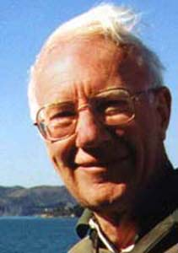  Dick
A highlight of the year was a trip to San Francisco in October, for an informal, high-spirited five-day fraternity reunion, followed by a week-long frolic around the Bay Area with cousins who live there. Activities ranged from sipping at Sonoma wineries and touring the Gold Country, to Eee-haaa-ing at a Cow Palace rodeo.
But THE highlight of the year - after than the arrival of Steven - was Arthur's floating 40th birthday party.
Arthur and his closest friend turned 40 in November within a few weeks of one another. Arthur's friend's wife laid on a most jolly joint birthday party, decor oriented around wine and fast cars, at the Chateau Pomije, a café in Cincinnati. The party then moved a bit eastward to where it could include Arthur's European family and friends, to another château (rather larger) in Chantilly, just north of Paris, under the aegis of Arthur's sister Sue. | A Splendid Party.....  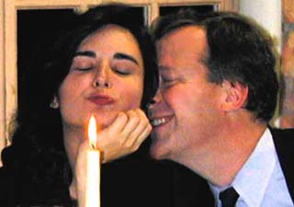  Happy Birthday Arthur! | A one-day foraging run to Arthur's favorite champagne house in Reims a few days before the banquet, assured that the champagne would flow like, well, wine. Guests came from all over Europe, and Arthur's lovely friend Maite came over from the States. A particularly gratifying moment occurred when, as a surprise to all, Arthur's brother Peter appeared, having flown over from the US for the evening.
Lois and I, having bestirred ourselves to cross the Atlantic for Arthur's party, elected to stay in Europe for the month. I mean, once you find yourself in the leisured class, you might as well make the most of it, right? So we arrived in France ten days before the party, and after it was over, we spent a few days visiting friends in the south of France, then went to London for a ten-day visit with son Richard and his wife Ishraq. We'd been in London before, but always as visitors, never really experiencing the lives of residents. Ishraq was the most gracious hostess possible, and while Richard worked, she escorted Lois and me through many non-touristic delights of the city. We didn't get back to Cincinnati until mid-December (which is why this is a New Year's and not a Christmas letter).
Our holiday in Hilton Head last March proved to be as pleasant as we'd hoped, and we'll be going there again this year, for six weeks, starting mid-January. These escapes from the Midwest's winter Gloom Period have a good chance of turning into annual pilgrimages.
Actually our total sojourn in the South will not be six weeks, but eight. The last full "Family Christmas" we had together was at the Club Med in Ibiza, in June '99. We celebrated Christmas in June because assembling our far-flung family over the actual holidays is close to impossible, something akin to trying to keep 14 puppies under a blanket. Then, once we were unhooked from seasonal constraints, we realized we were also free to choose a locale that was balmy, offered baby care….. and had French cuisine! Thus the Club Med. That holiday formula worked so we'll be doing it again this coming March, tacking onto our Hilton Head sojourn two weeks at the Club Med in Port St. Lucie, central Florida, for all 14 of us.
Our descendants continue to present moving targets. There's been an exodus - a reluctant one - from the Netherlands.
One set of émigrés was daughter Sue, her husband Jan Willem, and their sons, Willem and Nicholas. They'd been expecting Jan Willem's next assignment would be in the US, but when he was offered the job of site manager for GE's plastics operations in France, the opportunity was too good to turn down. They're now settled in a bucolic community among horsey estates, an hour north of Paris. Not a bad swap!
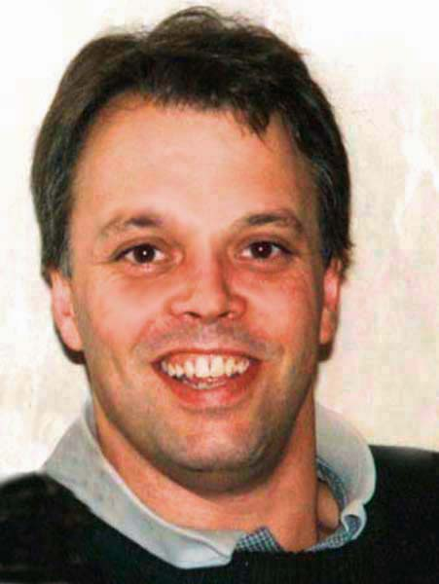  Jan Willem | 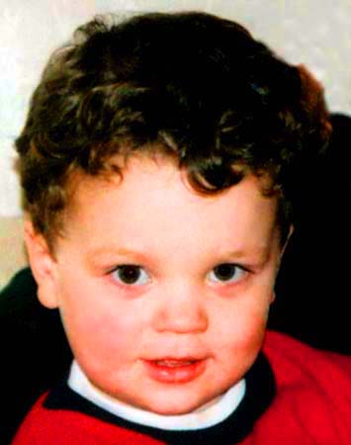Nickie |  | 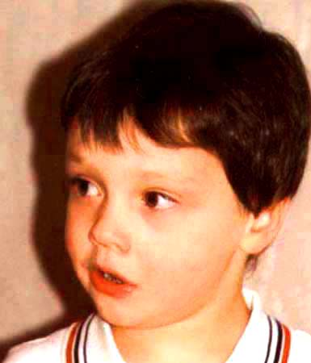  Willem |  | 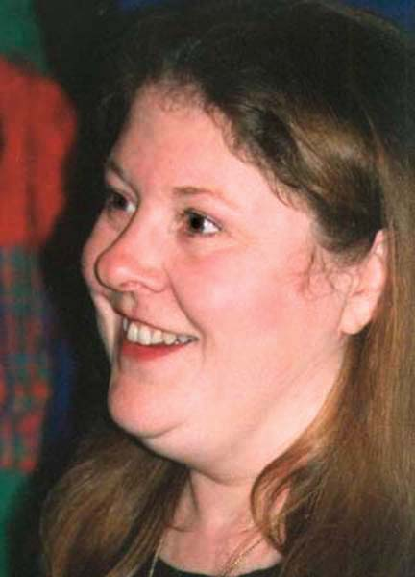  Sue
Son Arthur's gala entrance into the power phase of his life, his 40's, has been accompanied by a healthy though not especially welcome consolidation of his travels - his job of developing packing machinery for Procter and Gamble is now bringing him to Indiana and New York, rather than to, say, India and York. |  | 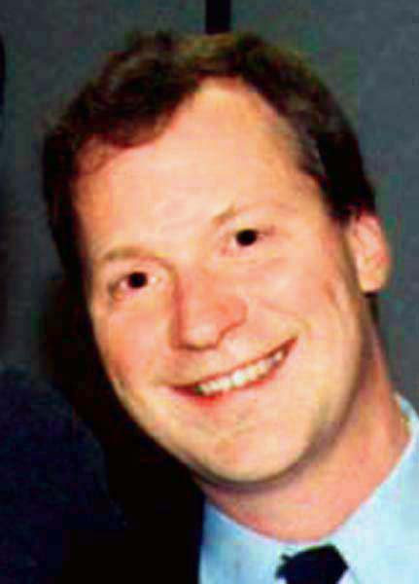  Arthur |  | We hope for him that this diminution in the exotic aspects of his travels soon shall pass. To keep fit, he's taken up the sport of Biathlon, which is a combination of running and rifle-shooting, a derivative of Nordic ski-and-shoot, designed for those unblessed with a large supply of chronically snowy mountains.

The other set of émigrés from the Netherlands was son Richard, his wife Ishraq, and their two children, Samer and Lila. When Richard's (Dutch) company merged with a British firm, Richard and family perforce had to move to London. They've taken a house west of town, midway between city center and Richard's office near Heathrow, so Richard commutes against traffic, and they can get easily go downtown during lulls in the everlasting rush hour. Though Richard alas doesn't get to do this very often: his business in 1999 was too successful! It attracted the avid attention of all his competitors, and the consequent pressures on him have severely constrained the time he has to enjoy that wonderful city.
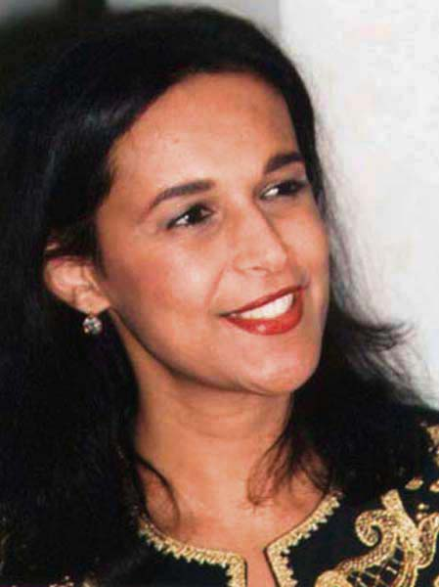  Ishraq | 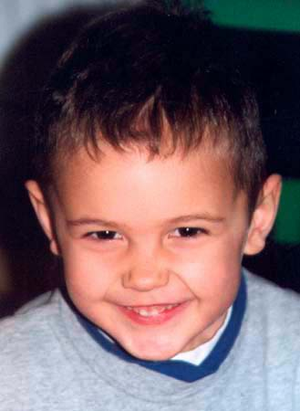  Samer | 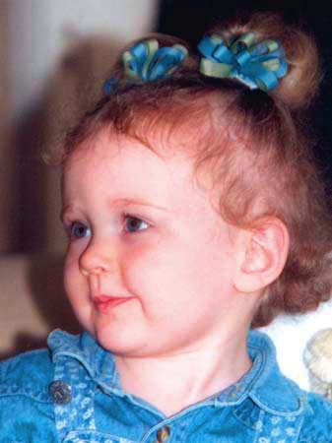  Lila | 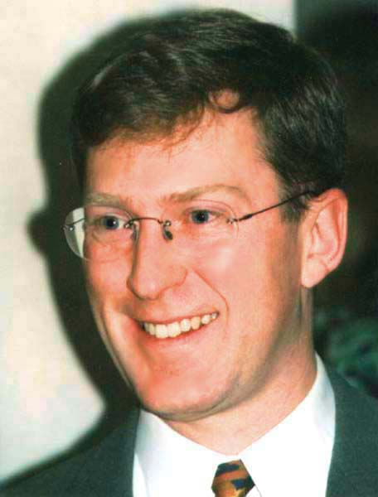  Richard

Son Peter and his wife Lisa are starting to emerge from the "Will I ever get a good night's sleep again?" phase of first-time parenthood. Peter's job, which he loves, is the training of IBM's clients in use of the networking backbone of its newly launched and much touted "E-business" product line. There's been a lot of travel, and though some of it is interesting, it's fortunate that it's now diminishing in frequency; the technology has grown so complex, and its equipment so massive, that many of the training seminars can no longer be brought to the clients - the clients must come to Peter (even as I write this, though, he's in Nice). Lisa is currently taking leave from her job (foreign-currency derivatives compliance officer!), to be with the newborn Steven, and is wrestling with that modern dilemma: career versus stay-at-home mom. Whatever course they choose, we're confident they'll do it right.
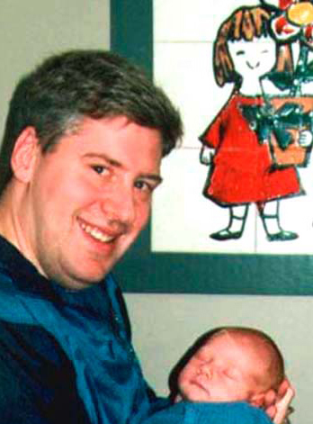  Peter And Steven | 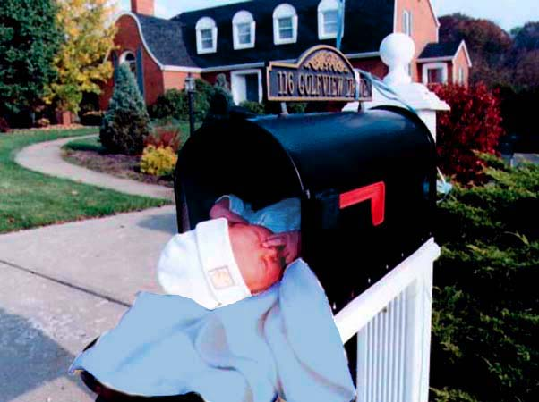  Special Delivery

May your entrance into the third millennium see you in robust health, and bring you peace and prosperity.
Cordially, Dick and Lois

