Christmas Letter from the Neergaards, December 1999

Well, there's been a pause in the Baby Bombardment. After the arrival of our first two grandchildren in 1996 and the second two in 1998, a quietus has prevailed during 1999. Perhaps the Y2K will bring more than just bugs.

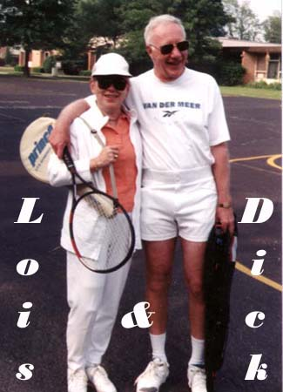
I will not dwell on details of our cheerfully non-workaday lives, but topics are: our struggle, two steps forward and two steps back, to develop our tennis game past the beginner stage; our dream-on attempts to make a garden grow in the face of vindictive Nature (she resents my cheek, aware that I was brought up on the sidewalks of Manhattan); ski runs (dashes?) down the 30-second slopes on our local hill when there's snow; the rare nuggets unearthed during genealogical forays, and strangled Eureka's as I attempt to master (hah!) construction of a family web-site. Lois, for her part, is getting ever more creative with her quilting.

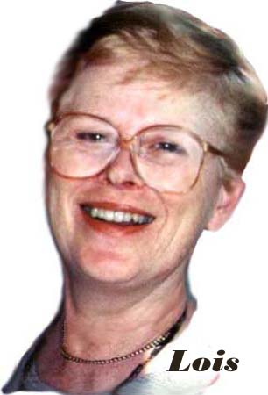

So..... on to the inevitable recount of travels. Our two sojourns of several weeks each in Hilton Head, in March, then in November, proved to be as pleasant as we’d hoped, providing as well a nice little boost - alas all too temporary - in our ability to hit a ball over a net. The November interlude was especially rewarding, since Peg and Todd Benton, and Louise and Bob Messner, were able to join us - a revisit to that exciting period of our lives back in the sixties when we shared the thrill of starting up the manufacturing end of P&G's business in Germany,.

After having gathered the last two Christmases at daughter Sue and Jan Willem's house in the Netherlands, the family decided that our Noël reunion in ’99 ought to take place when there was less pressure for time than during the actual holidays. Then, once free in time, we thought why not have it where it was nice and warm, and in a resort offering child care. We thus ended up on Ibiza, an island near Majorca off the coast of Spain, in June. And a lovely “Christmas” it was indeed! ....with tennis and water sports aplenty of course, but in no small part because the resort was French, assuring that both socialization and cuisine were outstanding.

As it’s turned out, we’ll have two family gatherings this year, the second occurring this (actual) Christmas when everyone except Sue and Jan Willem’s branch will be able to be in Cincinnati.
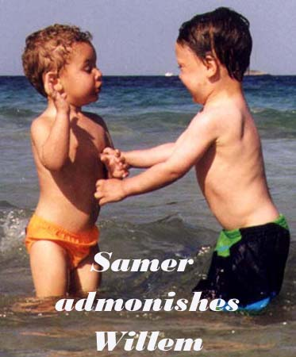

(S, JW & Cº will be making their pilgrimage across the Atlantic in February, to join us first in Hilton Head, then return with us to Cincinnati).

A highlight of the year was a trip Out West with Trig Treadaway during his October visit from Europe. It was just us guys. We split a week wallowing in those dens of iniquity, the delightfully laid-back New Orleans, then Las Vegas where appalling taste is so superbly executed. We spent our second week cleansing away the dissolution occasioned by these works of man by steeping ourselves in the glories of nature around the Four Corners area and Monument Valley, then driving through the Rockies to Denver.

Sue, her husband Jan Willem, and their sons, Willem and Nicholas:

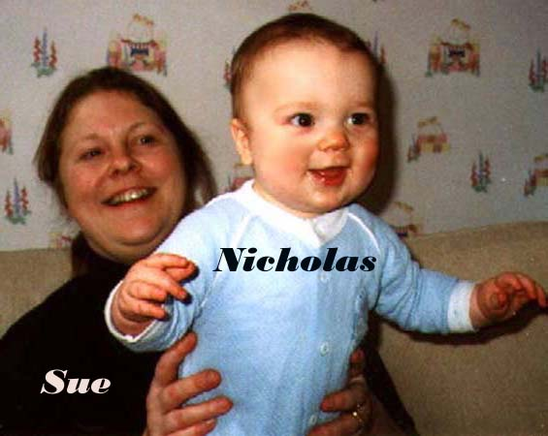
Sue and Jan Willem have, thanks be, almost finished the ambitious renovation of the ex-orphanage they moved into four years ago on the island of Tholen, southwest corner of Holland.

Sue, having left GE to bring up their two children, has found she’s traded a full-time job for an even fuller one. Willem, terribly two and oh so intense, is in particular a handful. Example: on boarding the plane to Ibiza he spotted a red button by the door.... the Evacuate Airplane alarm. Of course he pushed it of course and, well….. you can guess the rest.
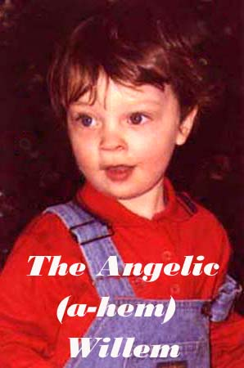

Jan Willem, production manager for GE’s Lexan in Europe, had not been shy in expressing the disdain for staff feather merchants that is so de rigeur for line managers. Accordingly, GE thoughtfully moved him into a staff position, responsible for safety in its European plastics division.
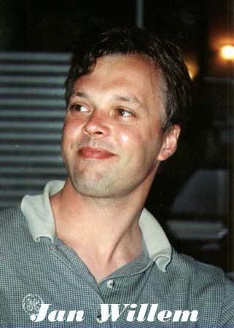

Soon adjudged to have been sufficiently reconstructed, he has now been allowed back into line, as plant manager of not one but two of GE’s plastics operations in the Netherlands.

Arthur

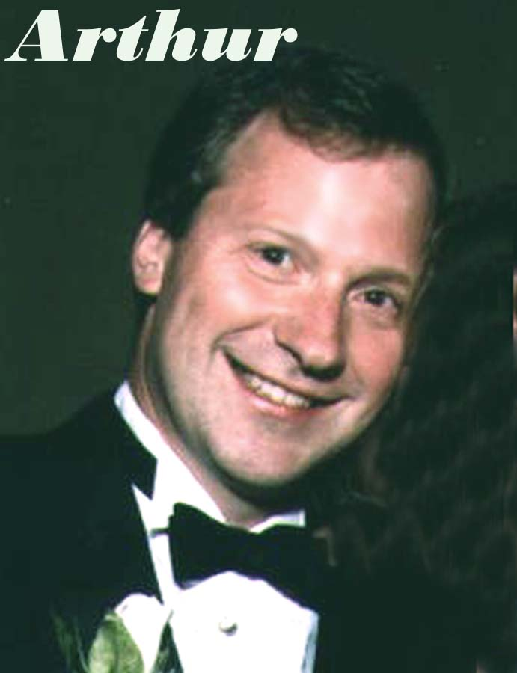
Arthur's career - developing packaging machinery for P&G's Paper division - is about to shift focus. He will now be charged with exploring new business opportunities in his field, rather than managing current projects. Since the "current projects" were global, he's been on extended international trips literally for years. His new area of responsibility will bring him back to headquarters here in Cincinnati, and will give him a chance, at long last, to stay home for a bit.

At the moment, though, he's still in Europe, whence, over Thanksgiving, he managed a couple of weeks' holiday that included diving in the Indian Ocean amidst hammerhead sharks, exploring the bazaars of Zanzibar, and, once, being awakened at 2AM by a hippo grazing next to his tent in the Selous game preserve in southern Tanzania.

Richard, his wife Ishraq, and their two children, Samer and Lila

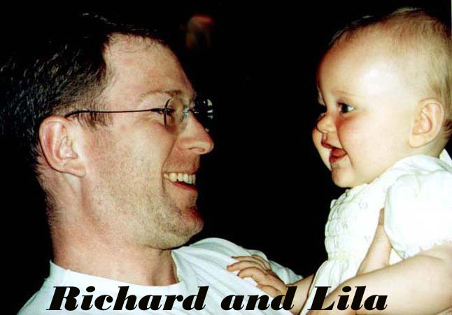

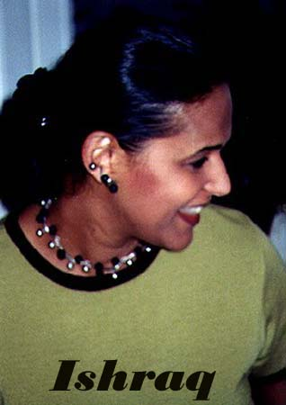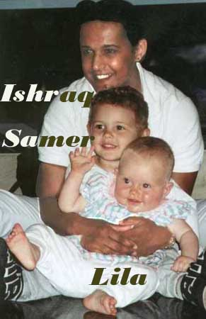
Richard's company, Benckiser NV (Dutch), has just completed a merger with a larger firm, Reckitt and Coleman (British), also in the consumer-products business, to form Reckitt-Benckiser. Richard had been Sr VP and Category Manager of Benckiser's automatic dishwasher business, which has the largest share of this global market. The merger occasioned a bit of breath-holding, but when the dust settled, Richard remained employed, a director of the merged company. He's rewarded himself with a silver Boxter, about the steering wheel location of which he'll have to worry when they move to their new headquarters in London next Spring. Their three-year old son Samer is already attending a British school in Amsterdam, and now calls Ishraq "Mummy". Speaking of mummies, their one-year-old Lila, who never ceases to smile, has started to walk. "Just like the bride of Frankenstein", Richard tells us, "arms outstretched, wobbly, then a plop-down, followed by a big round of self-applause".

Ishraq remains on retainer to Benckiser, spending a few days a month in Tel Aviv where she continues to guide the development of Benckiser's Israeli business in the West Bank, a task at which she's been singularly successful.
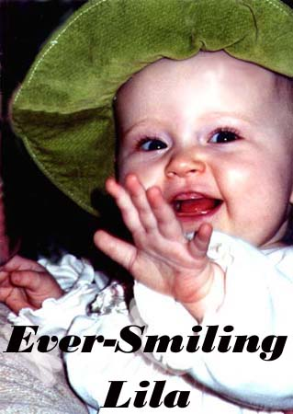

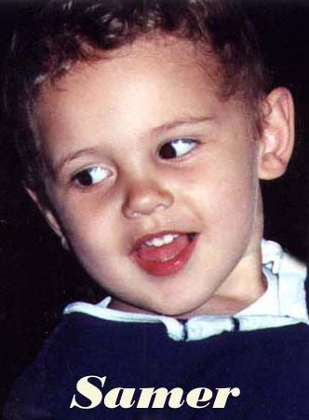

They'll be here Christmas; then the babies will stay with us while Richard and Ishraq proceed on to Hawaii, to join friends atop Diamond Head where, as the Y2K arrives, they'll be among the last in the world to toast the 20th century.

Peter and his wife Lisa

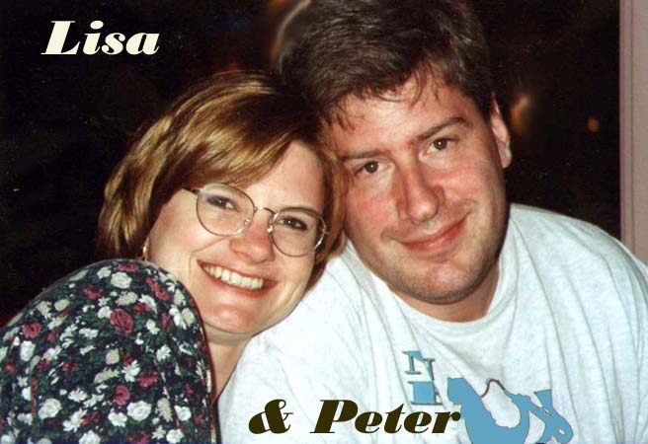
Peter's company, Transarc, was in July fully assimilated by IBM, and Peter is now of the Big Blue, for whom he trains clients' IT officers in use of its "E-business" product line. He's on the road much of the time, which can be exciting for a while (London, Rio, etc), but has its drawbacks for newlyweds (they are).

Lisa is now Compliance Officer at PNC Bank for Foreign Exchange and Derivative Trading (wow!).

They've just bought and moved into a new house (in their spare time), located in a suburb south of Pittsburgh. They too will be here with us over Christmas, bless 'em.

May you have a joyous holiday season, and a new millennium that is both happy and prosperous.

Cordially,

