Dear XXX and YYY 2/18/97
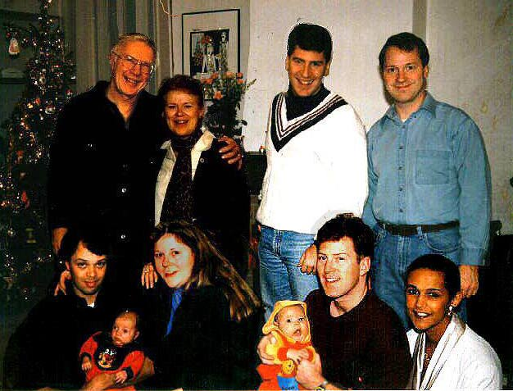
This is a "Happy New Year!" greeting. We weren't able to get to press with a letter for Christmas this year, but we treasure our traditional annual correspondence far too much to skip it altogether.

Actually, we have what I think is a pretty good excuse. We were immersed for the last four months of the year in genealogy - not in its research but in its furtherance. Until that time, we'd been grandchildless and somewhat grumpy about it, to the extent of every year denying our children the easy out at Christmas of giving us a video camera ("...don't want one 'til we have something worth videoing - like a grandchild"). Then last March, Sue, calling from Holland, dropped into the conversation something about giving us a camcorder for Christmas. In the midst of my expostulation that I didn't WANT a..., the penny dropped. "Sue - are you pregnant?". "Yeeees", said she, coyly, due in November! Our euphoria was still buoyant when, a few days later, our FAX machine clattered, printed out a big blotch. Damn, I thought, thing's broken. But then I squinted.... there was lettering in the margin. Looks just like a sonogram I thought. A few minutes later the phone rang; Richard, calling from Tel Aviv. It was a sonogram, their baby's first picture; Ishraq was due in October. At that point, Lois advised that we stop answering the phone.

Sue and Jan Willem came to Cincinnati in July to do baby-equipment shopping. Jan Willem and I, not wanting to be burdens on the ladies in their Mall Crusade, sacrificed ourselves and headed Out West. We meandered for ten days, starting in the astoundingly cheerful Las Vegas, (we hit 100:1 on our third quarter, then quit), were duly awed by canyons Bryce, Zion, Goosenecks, and Grand, made pensive by the pueblos of Mesa Verde, Aztec and Chelly, projected into the great old Westerns of Zane Grey in Moab and of John Ford in Monument Valley, bounced over Colorado rapids in a rubber raft irreverently called a rubber ducky, and jounced over the San Juan Mountains on a narrow-gauge steam-train which deafened us with bells and whistles, drenched us in steam and pickled us magnificently in cinders. My enormously affable and enthusiastic traveling companion and I finally headed east into the Rockies, to be purified by hiking through the crystalline air of alpine meadows, finally to fetch up in Denver for our return to what I suppose is the real world.

The other Great Fun Trip of the year, to India, had taken place earlier, in February. Trig, Waltraud and I hired a car and driver and spent a month touring first Rajasthan, then Mysore in the south. Traveling in India was a deluge of sensation.... enormous, opulent palaces, romantic desert forts, mystic temples, fierce Sikhs and gentle Hindus, rainbow-flocks of willowy ladies in diaphanous saris, spicy smells and brilliant colors in street markets, a heart-stopping cascade of voyagers along the dusty roads - cars, camels, mopeds, trucks, goats, bicycles, cows, pedestrians - all moving at their own speeds, weaving and swirling like smoke in a wind. Perhaps the strangest feeling of all however occurred when we returned to the airport back in Frankfurt, where I was momentarily shocked by the cold isolation in which the people scurrying about us seemed to have wrapped themselves, everyone intense, focused inward, radiating discontent. After a few minutes though, I readjusted to the normalcy of our rich end efficient Western world, and my shock evaporated.

In September, Ishraq flew in from Tel Aviv to be with us for her lying-in period and eventual birth of her baby (even though the child would have a US passport, its stating "born in Israel" would have made it impossible for him to visit his maternal relatives in several Mideast countries; thus did the ill wind of Mid-east politics blow an interlude of charm and beauty into our lives). Ishraq was joined by Richard a clever 36 hours before Samer arrived on October 19th. Mother, baby (and father) did so well that they were able to fly to

Israel three weeks later, leaving Lois and me free to pack our bags and get quickly over to Holland to be with Sue, who by then was herself due any day. A week after we arrived, and precisely five weeks after Samer was born, his cousin Willem appeared, also healthily, thanks be. For the next several weeks Lois did those heroic things that new mothers' mothers do, and in due course everyone settled into a happy normalcy (with the possible exception of the two fathers, who were - and are - bursting with pride, as if they'd done the whole thing themselves).

The village of St Annaland, where Sue and Jan Willem live, is on an island in the North Sea off the Dutch coast, hardly your winter vacation paradise. Nonetheless, we elected to stay on to year end so that the family would be able to come together again this year for Christmas. Richard, Ishraq and Samer flew up from Tel Aviv, Arthur in from Leeds in England where he's been on an extended business trip, and Peter over from Pittsburgh with his lovely friend Lisa. Bless 'em all. But that's how come our Christmas Letter got displaced.

Sue and Jan Willem, as of year-end, were still both with GE, in its plastics plant in Bergen-op-Zoom - Sue with Human Resources, Jan Willem in charge of Lexan production. Sue however has this month made a different career choice, to devote full time to the rearing of Willem and to completing the restoration of the hundred-year-old orphanage she and Jan Willem bought last year - a worthy project, subject of a recent feature in the regional newspaper, and one on which they've made enormous progress, but still have a dauntingly long way to go.

Arthur spent the year developing new packaging machinery for P&G's South American locations. The primary vendor has his engineering headquarters in England, his assembly shop in Belgium and a prototype machine in Switzerland; P&G's Technical center for the project is in Venezuela, the first client factory in Argentina. Arthur spent all of one month in the US, time enough only to host his annual party for the Riverfest fireworks, for which the balcony of his Mt Adams apartment offers a spectacular view. This year promises an expansion of that initiative, into China, entailing a transfer from P&G's R&D Division to Engineering.

Richard and Ishraq are starting up not only a family but a business. Richard is General Manager of Benckiser's (a German mini P&G) new Israeli subsidiary. Their life is not dull - business is directly affected by the ebbs and flows of Arab-Israeli turbulence, particularly Ishraq's, who, acting as marketing consultant, travels frequently to the West Bank. Life in Tel Aviv, they report, is much like that in a southern European city, though the weather tends to be sunnier than the dispositions of some of its war-weary citizens.

Peter, comfortable in the Carnegie Mellon University community, has moved from programming current computer operations to developing upstream computer languages (don't ask), about which he's quite excited. He and his friend Lisa share great enthusiasm for sports and the outdoors, and in addition each has taken up each the other's special hobby. Lisa too is now a supernumerary in the Pittsburgh Opera, and Peter has become a diver at the city zoo's aquarium, feeding sharks and cleaning their windows - from the inside - while waving at wide-eyed children on the dry side of the glass. So far only the sea turtle has bitten him.

As for us, we play tennis whenever weather permits, subscribe to the theater and opera; I do genealogy, gardening, and eclectic projects, Lois designs and makes quilts. When we can fit any of that in between trips. When Oh when does leisure arrive? (Never, I hope).

All best wishes for what's left of 1997
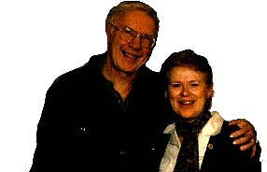 | 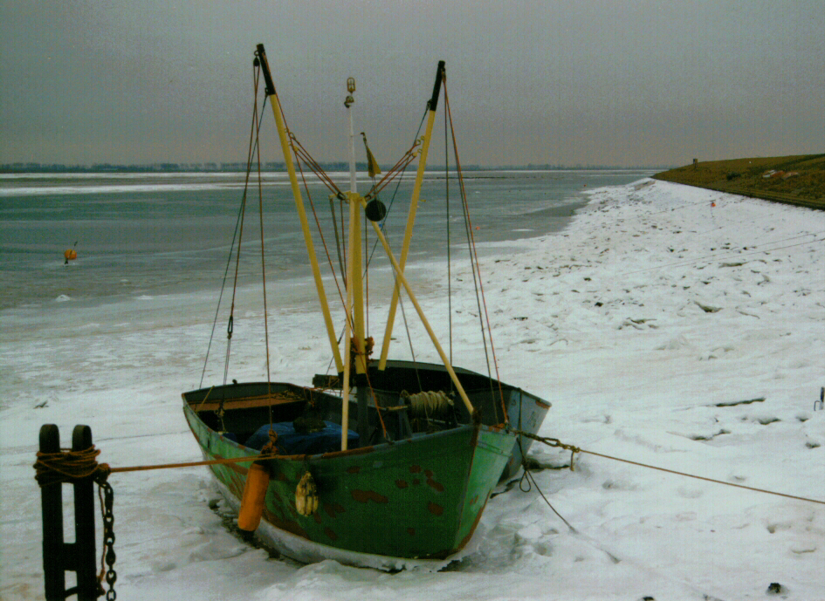 | 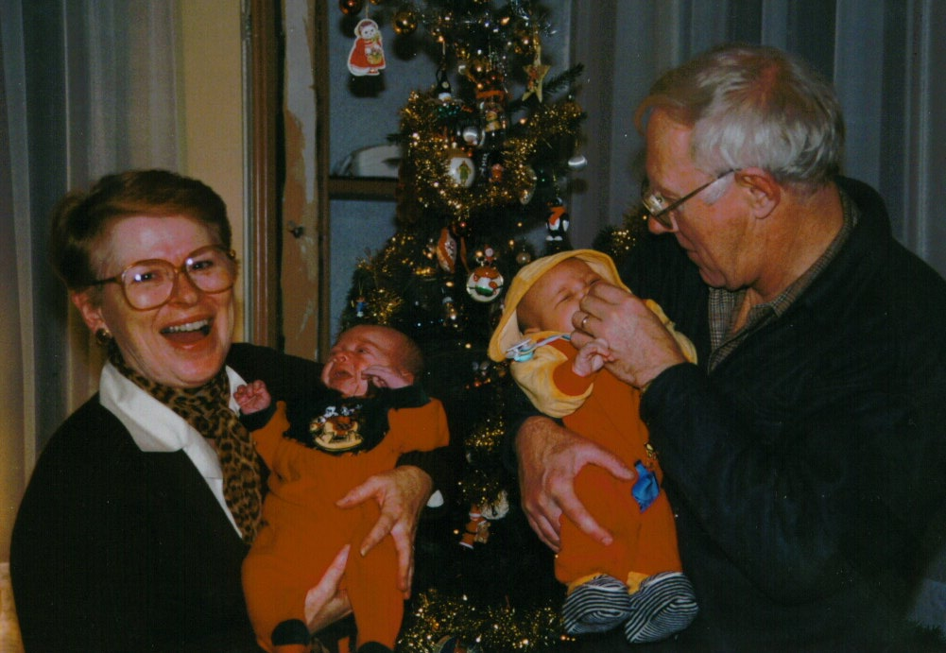
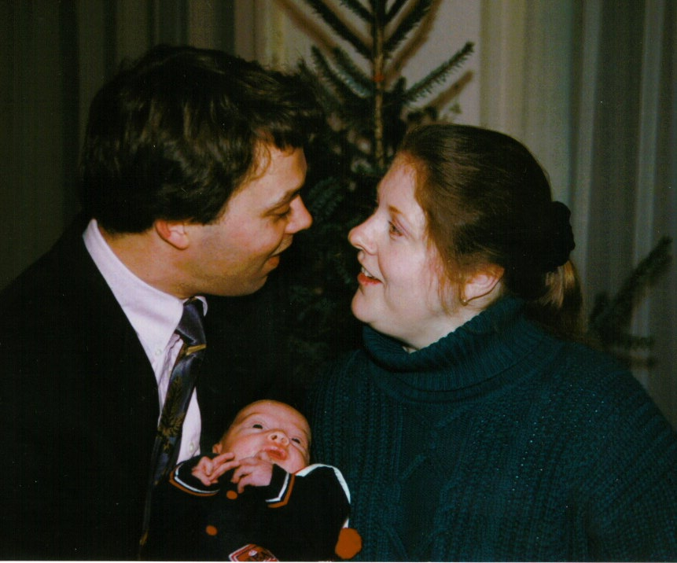 |  | 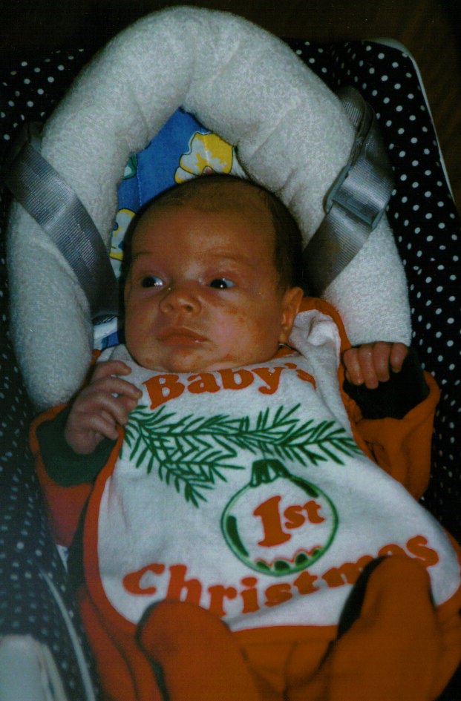
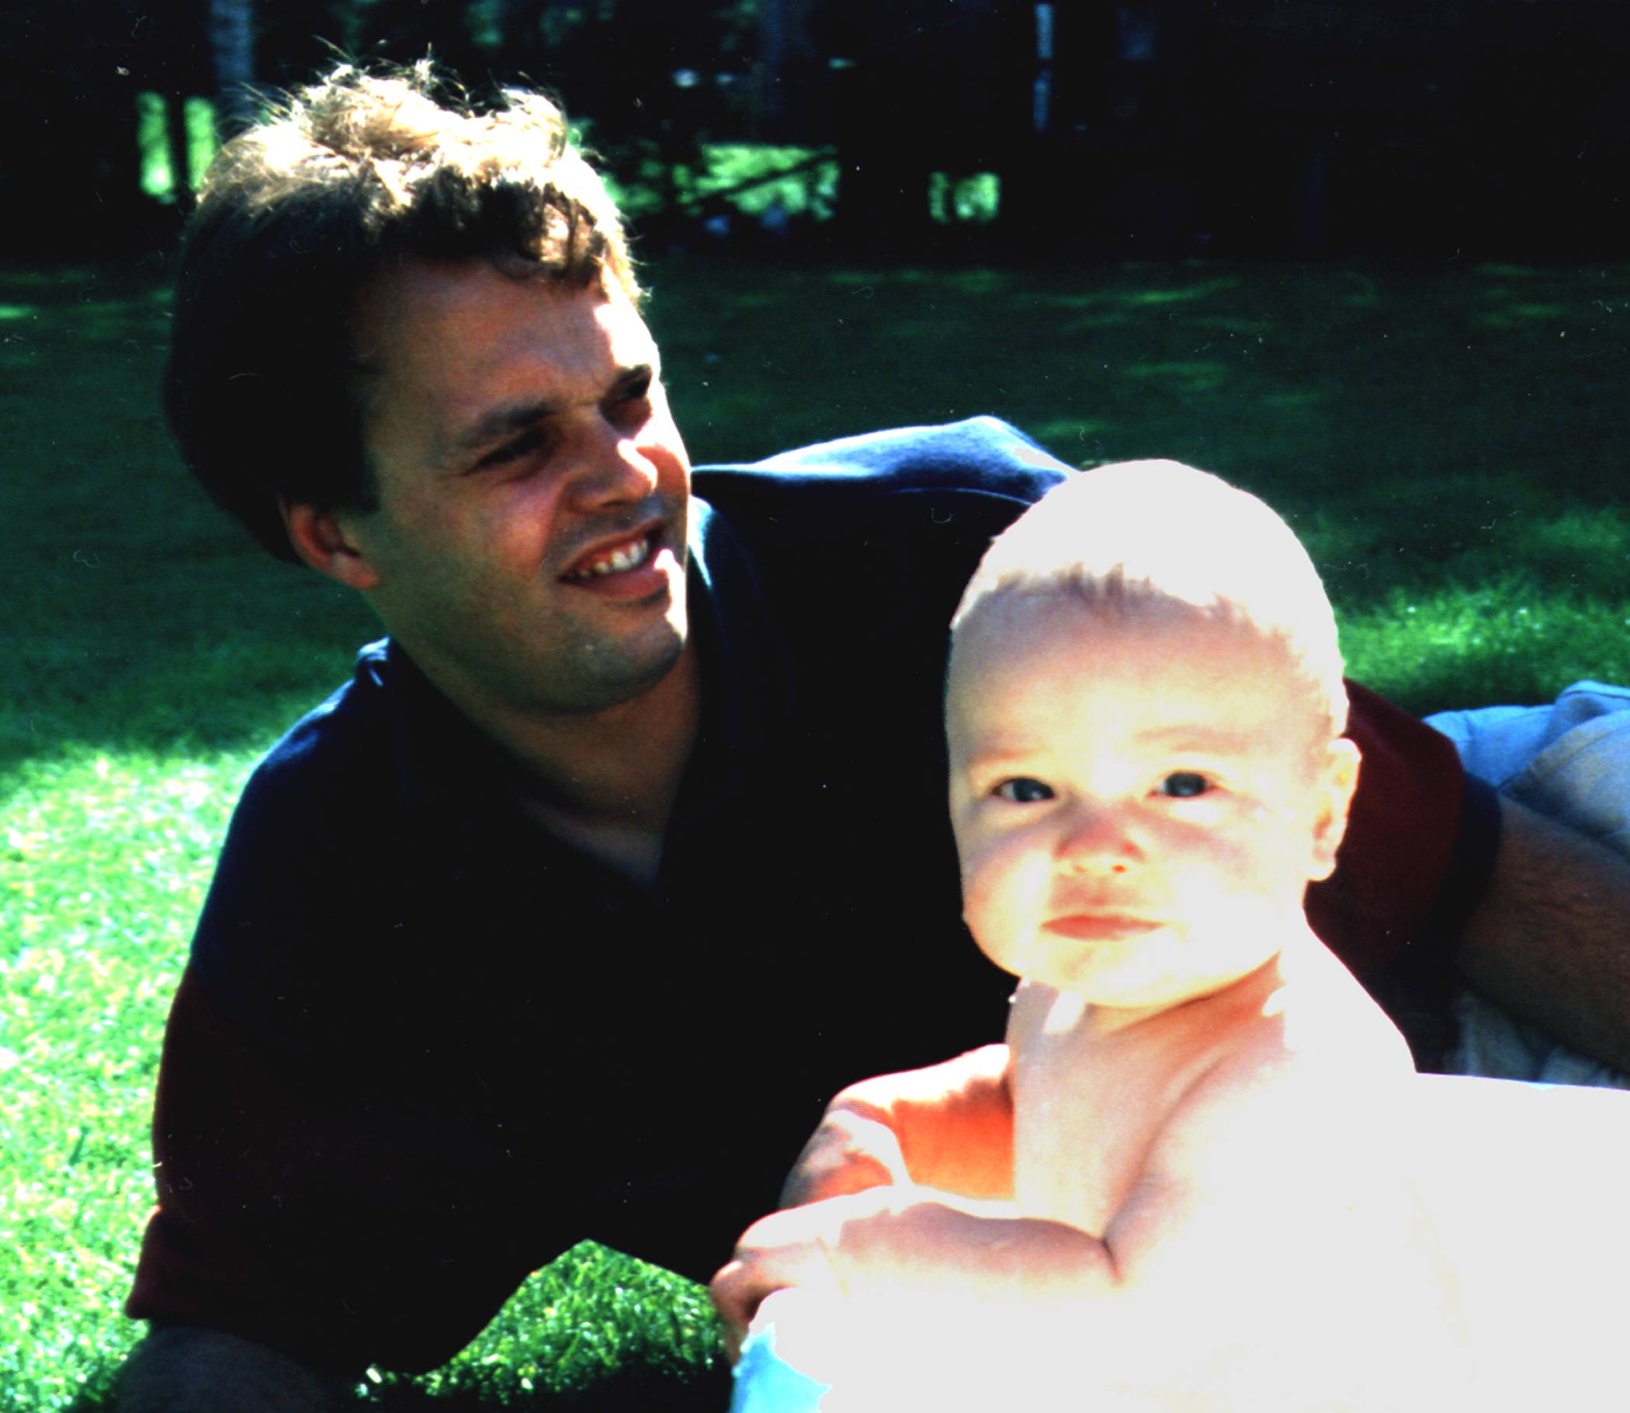 | 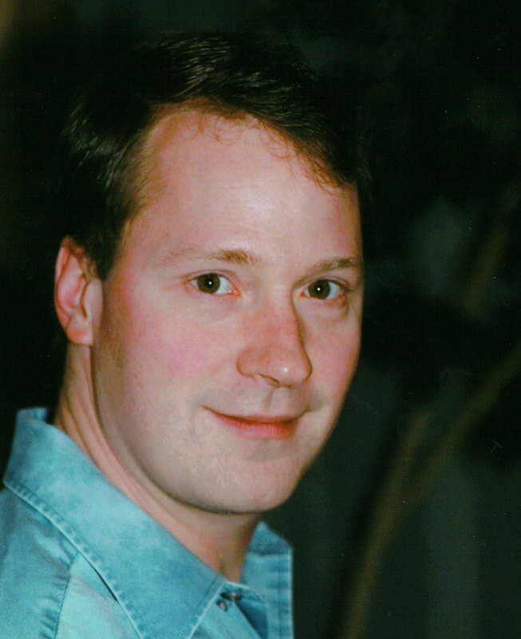 | 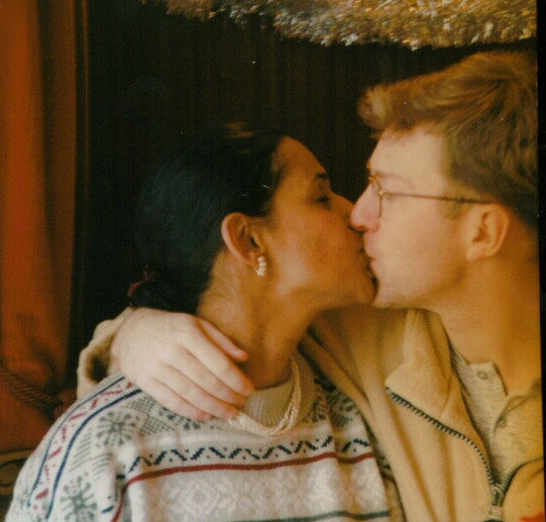
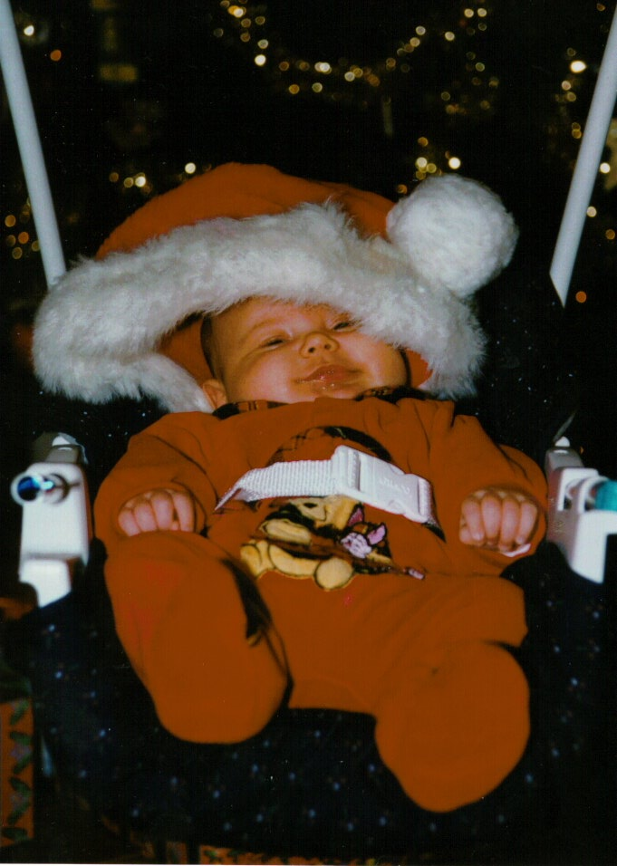 | 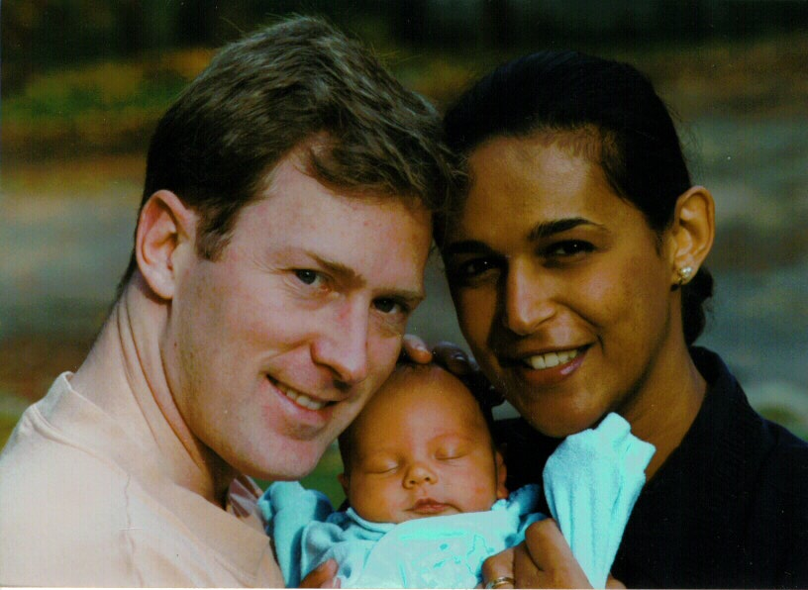
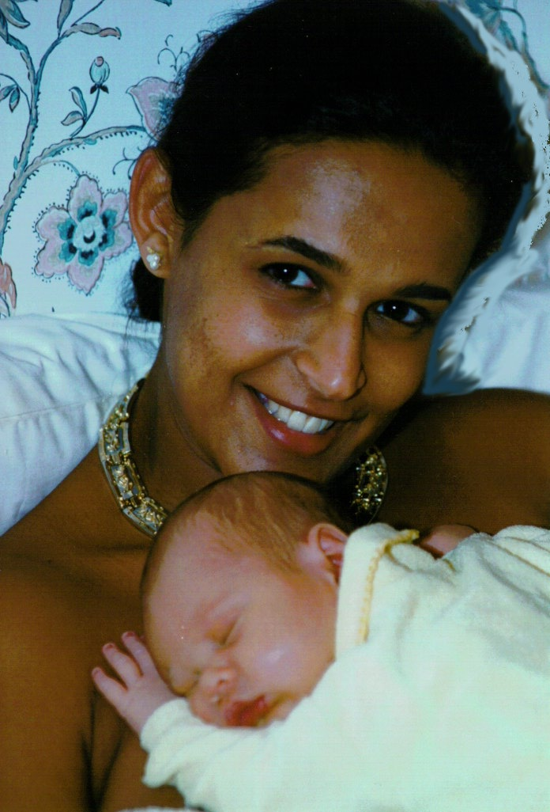 |  | 