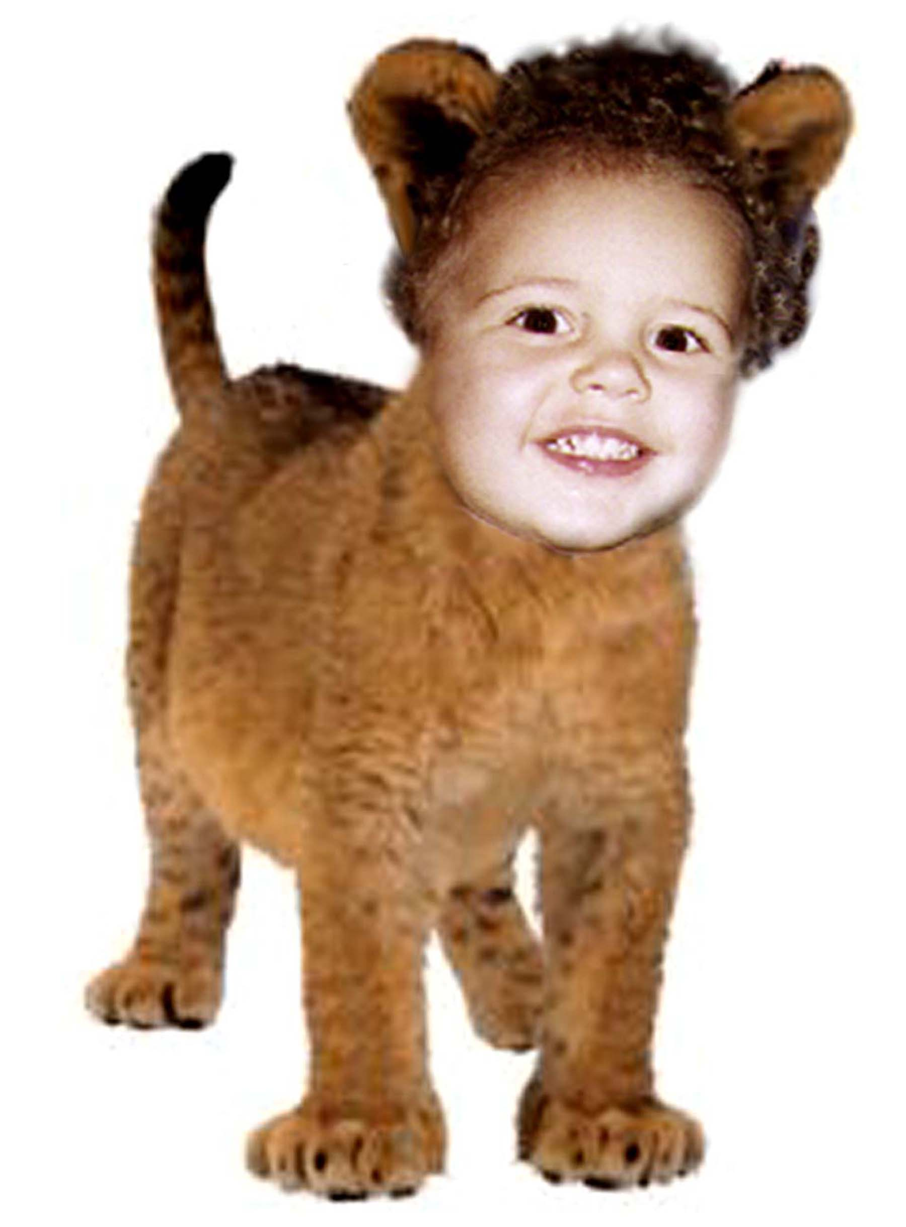

We

aren't

Lion!

Happy Birthday
Samer!

