You
are a
WINNER !

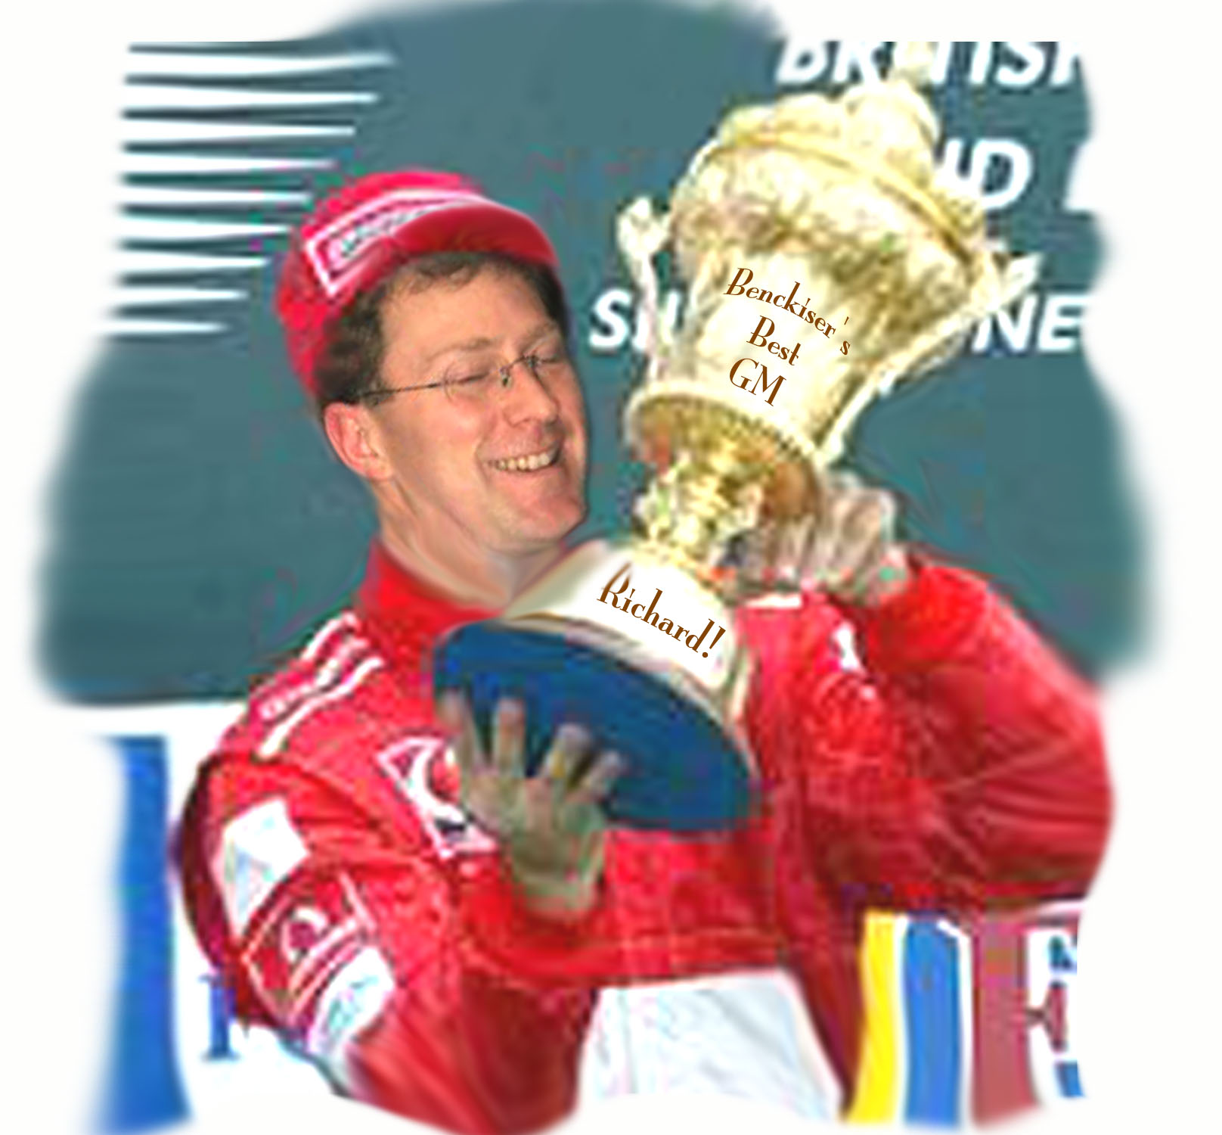 | Happy  Birthday,  Richard!  Love,

Every birthday is the finish line of another year
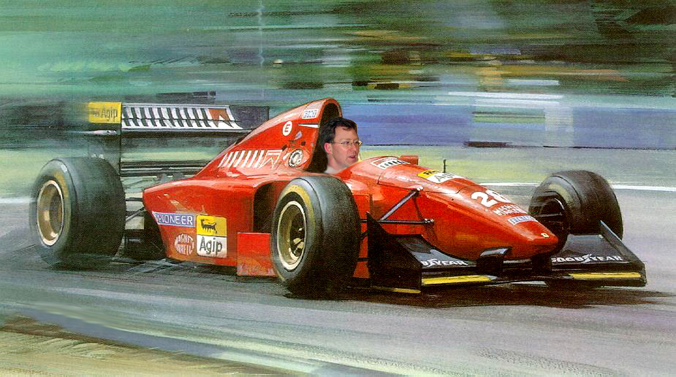
and once more…..

