Merry Christmas and Happy Holidays from the Neergaards
Mark Twain said he wanted to be in Cincinnati when the world ended “Because everything there happens ten years later”. Which suits us, the senior branch (and getting ever more senior, by cracky) just fine. Lois and I remain peacefully quiescent and in reasonable condition, snowbirding over the winter in delightful Hilton Head, and otherwise just being part of the gentle local scene in Cincinnati – socializing with friends, tending the garden, playing (at) tennis, and enjoying the (quite good!) local theatre, ballet and opera. | 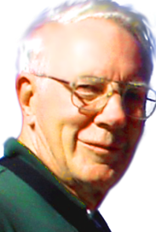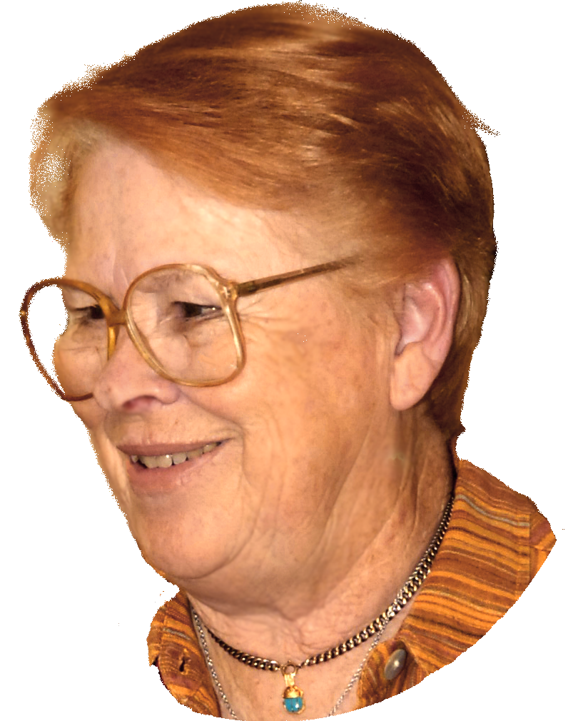
I did break out a couple of times (not Lois, who alas doesn’t fly), in May to Europe and Egypt, and in September to the Great Northwest for a triptych of reuning. I started this later idyll with a weekend of touring the Olympic peninsula with the admirable Bentons, then spent several days driving around the gorgeous Cascades with the well-loved Bradshaws (my college roomie and his wife), finally finishing in Seattle (what an amazing city!) for the biannual reunion of our fraternity brethren of the 50’s. It was indeed a splendid ten days.

The trip to Europe and Egypt in May was enormous good fun. I was graciously eased over my jet-lag by the Treadaways in Germany, then popped up to Holland to join with our Dutch branch, Sue, Jan Willem & Cº, who took me to Egypt. We spent a week visiting all the sites one is supposed to see, from Giza south; we rode on feluccas and camels (the kids did, anyhow), and spent a memorable morning in Cairo’s camel market (definitely not in the guidebooks). We then drove across the desert to El Gouna, a coastal resort on the Red Sea across from Sharm el Sheikh. Our Istanbul branch, Richard and Ishraq & Cº have a villa there, and joined us for our second week. Man, talk about Days of Wine and Roses! Think a surreal St Tropez at the edge of the desert.

Y’know - it’s really really nice to have kids who are willing to trundle you about, as once you trundled them.

But enough about us moldering fogies. Here’s the far more interesting news from our effervescent offspring:
Sue and Jan Willem (and Willem and Nick) [resident in a charming village south of Amsterdam, amidst meadows and canals]
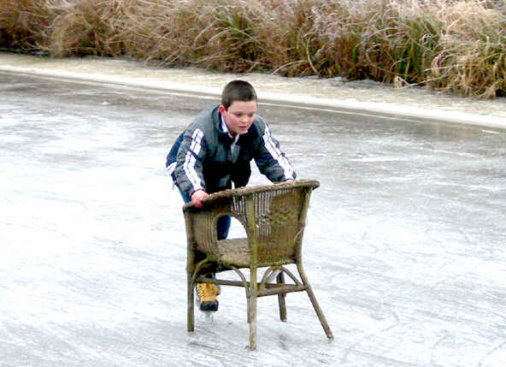 |  | The water around us, whether frozen or liquid, provides a lot of fun. Immediately after spending last Christmas in Cincinnati, we came home to a frozen country. In a Breughel-like setting, Nick quickly mastered skating skills, stepping out of our kitchen and onto the ice – with a chair. Then six months later, when the substance had sufficiently warmed up to melt, Willem and Nick enjoyed the water by sailing on it again this year, but now with increased speed, in a Laser and in a Catamaran. |  |  | 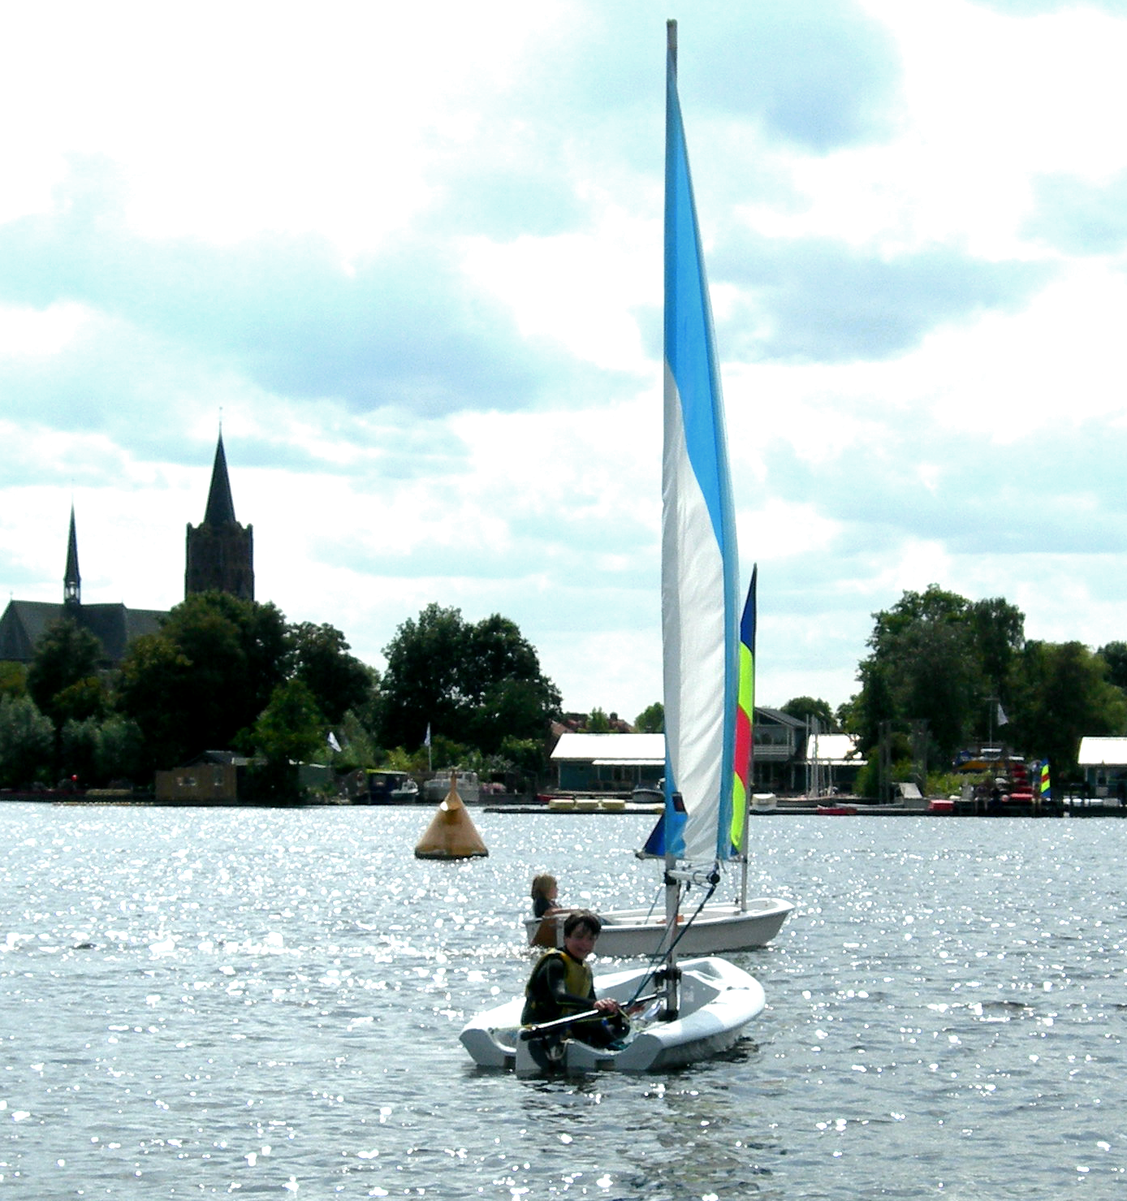
The use of wind energy is what the boyz share with their Dad. Jan Willem bought out the company he started last year and is now running his own business in rotor blade technology for wind turbines. The company now employs six people, is headquartered in Holland, has a branch in the US and in India, and is doing business all over the world. This means that travel has increased now to the point that Delta is sending us gifts from Tiffany’s. (We prefer the free drinks on board.) Sue is busier than ever, working at school and continuing to build her enormous world coin collection. She now has coins from countries the UN didn’t even know existed. Willem and Nick have changed schools; they now attend the International School of Hilversum. Nick decided to let wrestling be for a year after the health insurance companies of his opponents started grumbling; he’s joined the local soccer team instead, VV Sportief. Willem is …. um…. well… Willem is now a teen-ager.
 | 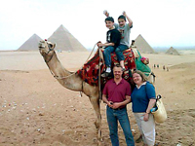 |  | A true highlight of the year was our trip to Egypt in April. This was the 10-year birthday trip for Willem and Nick from Gampa. We visited the main sights in Cairo, Aswan, Abu Simbel and Luxor, and spent a very relaxing couple of days | 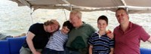SUE’S BIRTHDAY BANQUET – A PICNIC IN A FELUCCA ON THE NILE
 | in El Gouna with Richard and Ishraq at their house there…. شكرا لك. (= shuckran, or “Thank you” – the first words of course to learn when visiting a foreign land!)

